ASSIGNMENT 1

VIRTUAL BOX

DOWNLOADING AND INSTALLATION PROCESS

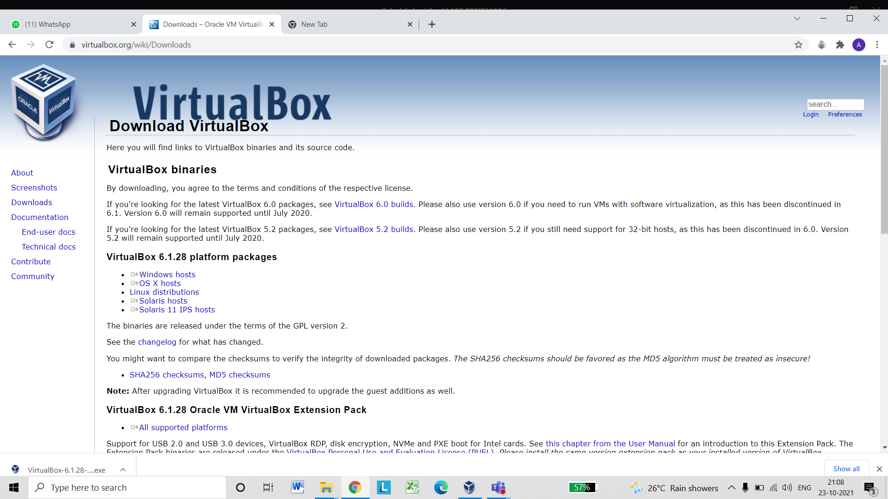

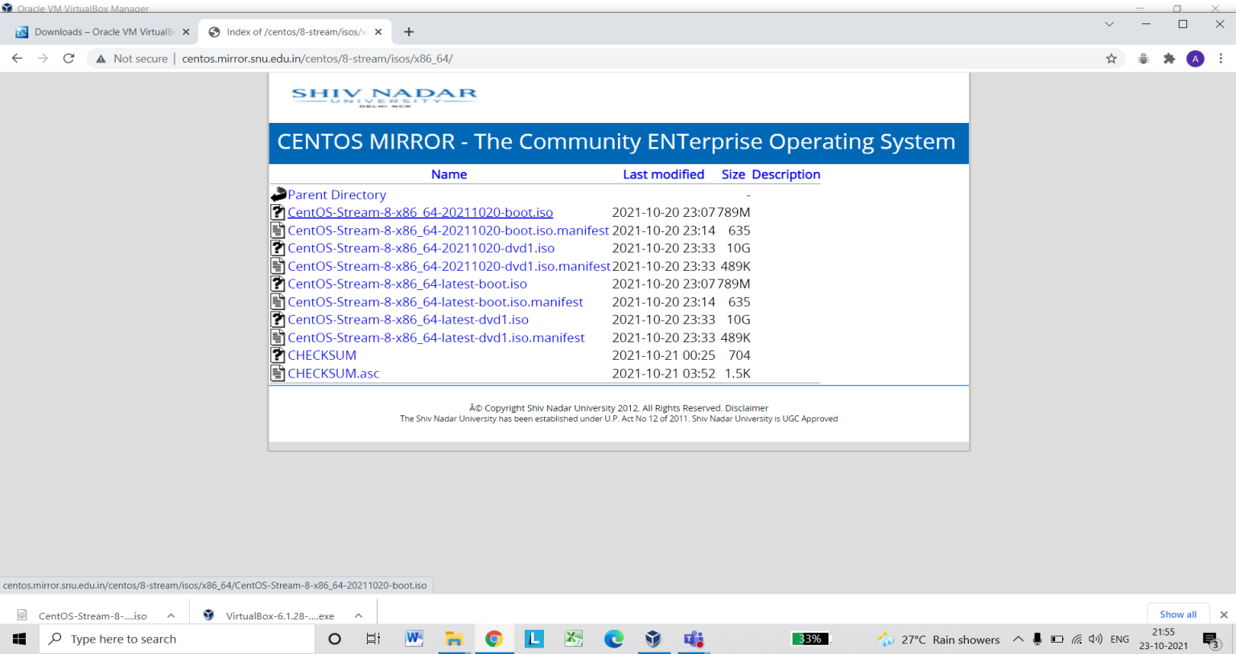

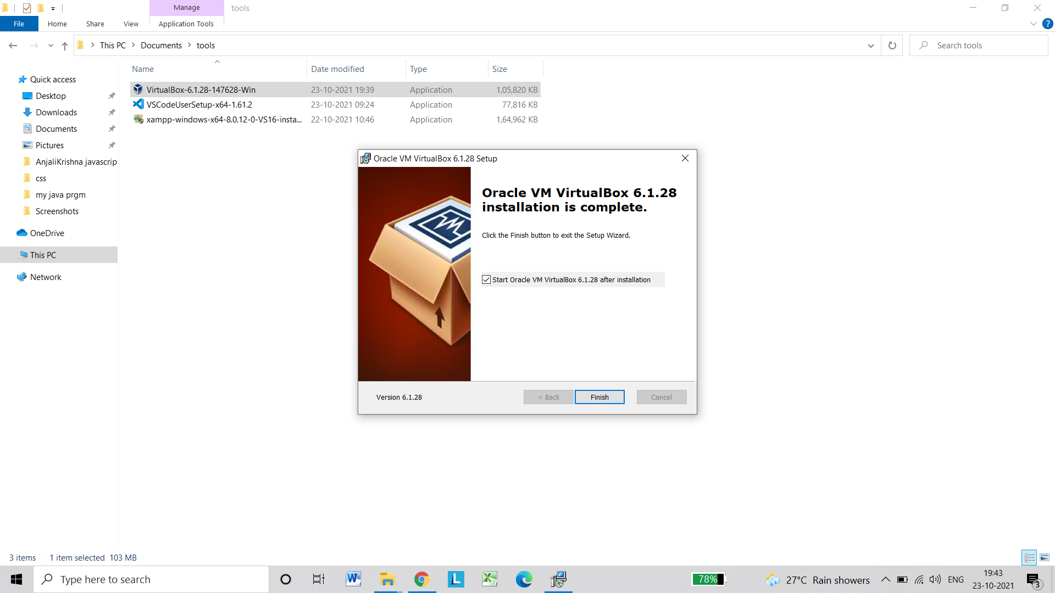

LINUX MINT

DOWNLOADING AND INSTALLATION PROCESS

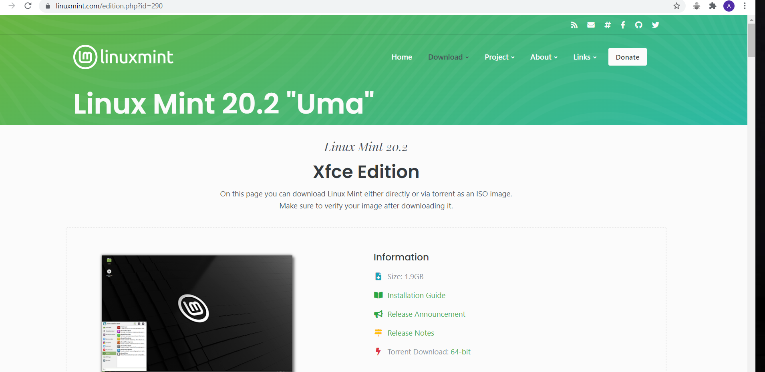

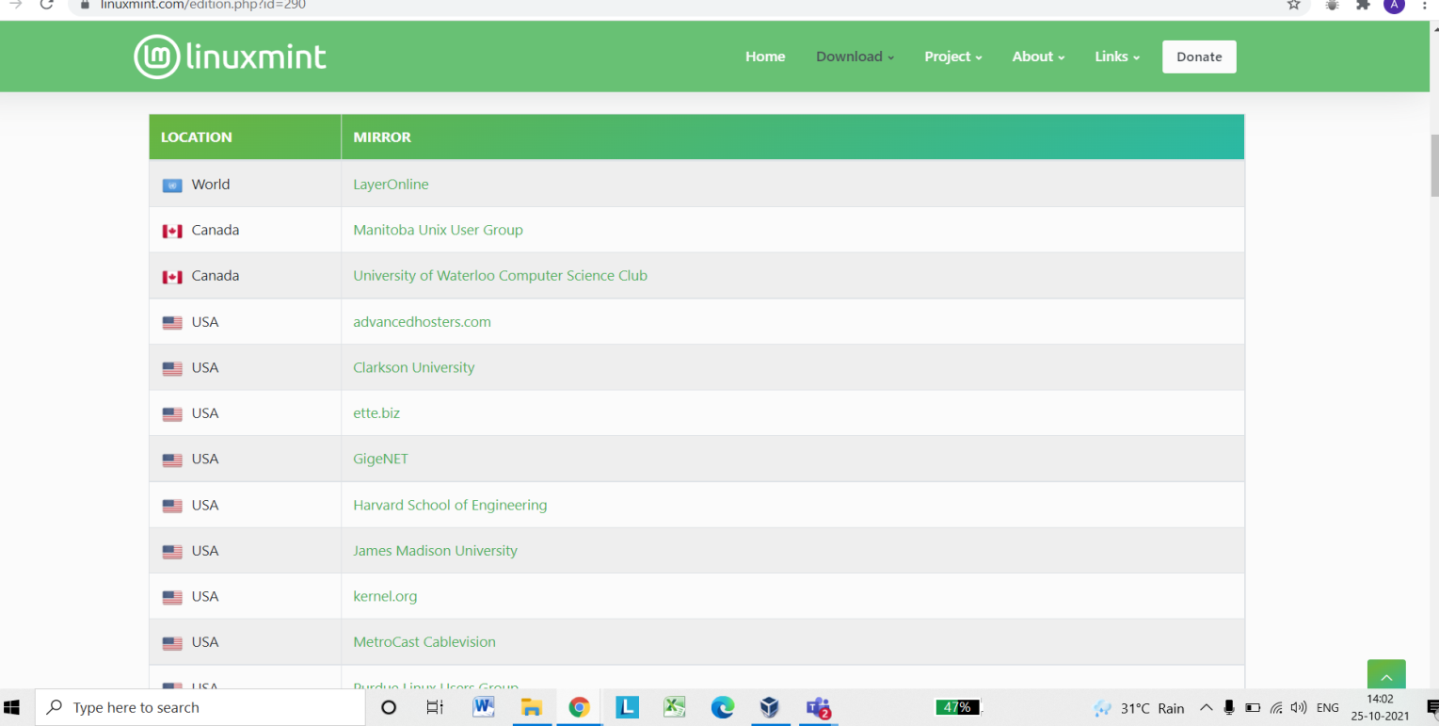

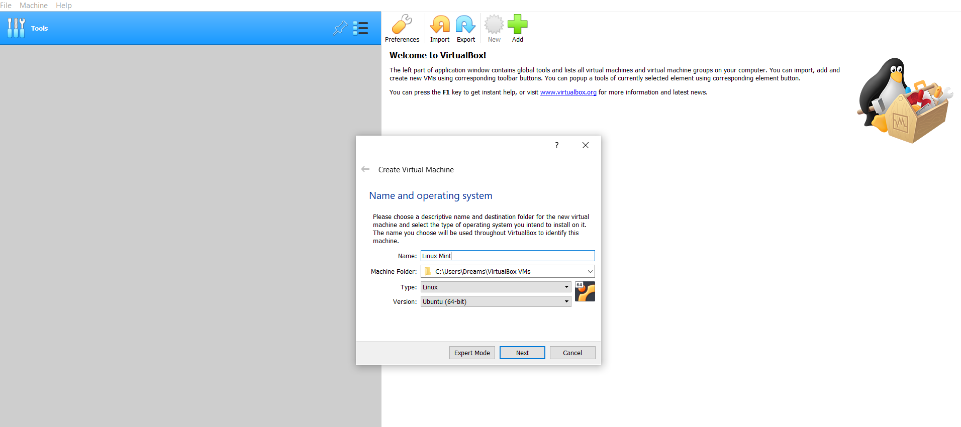

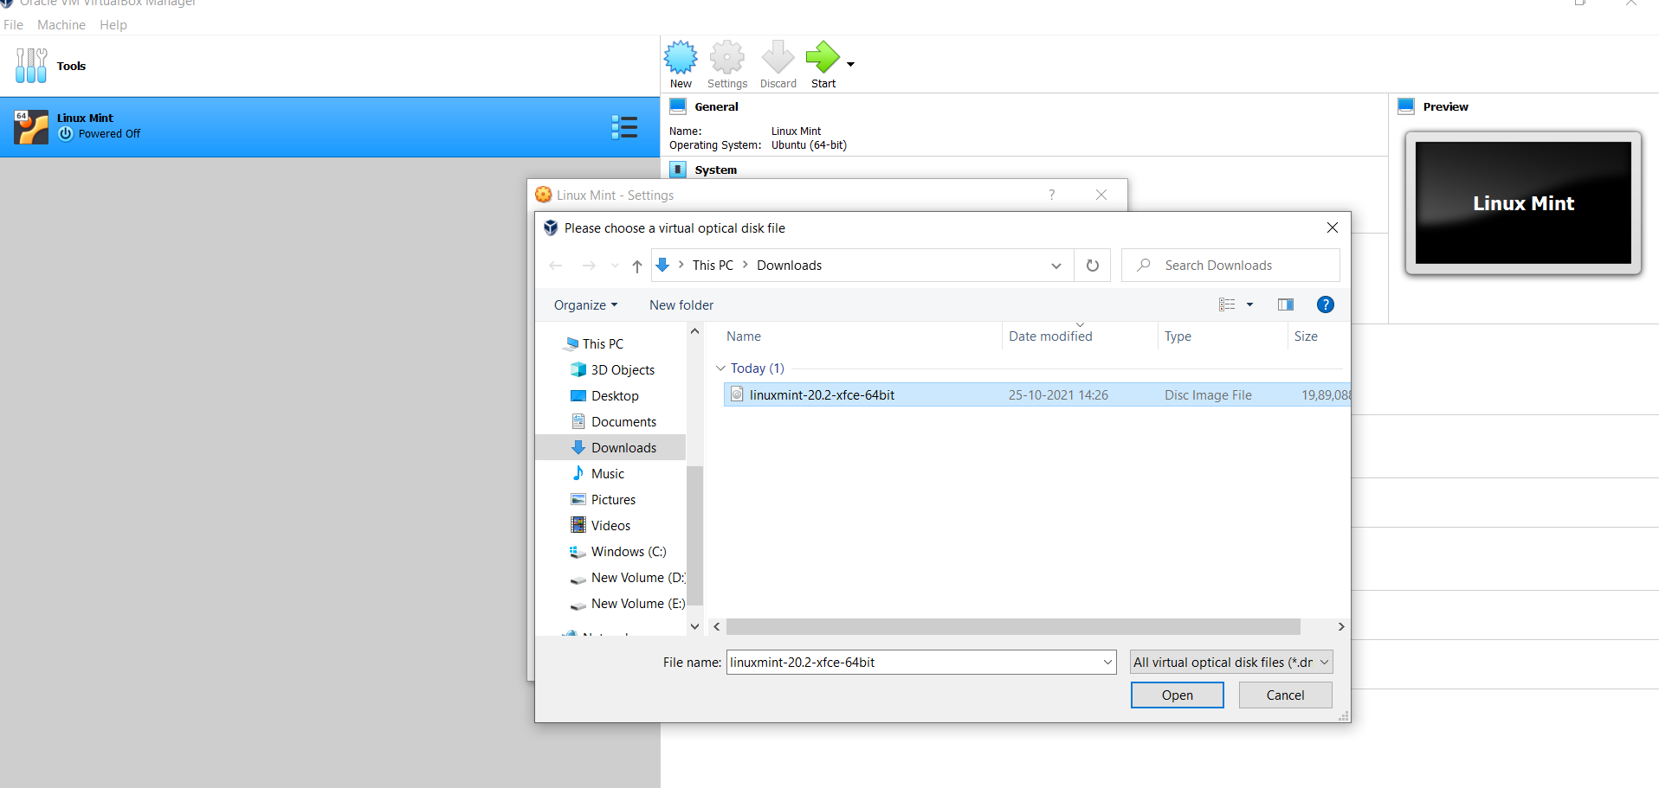

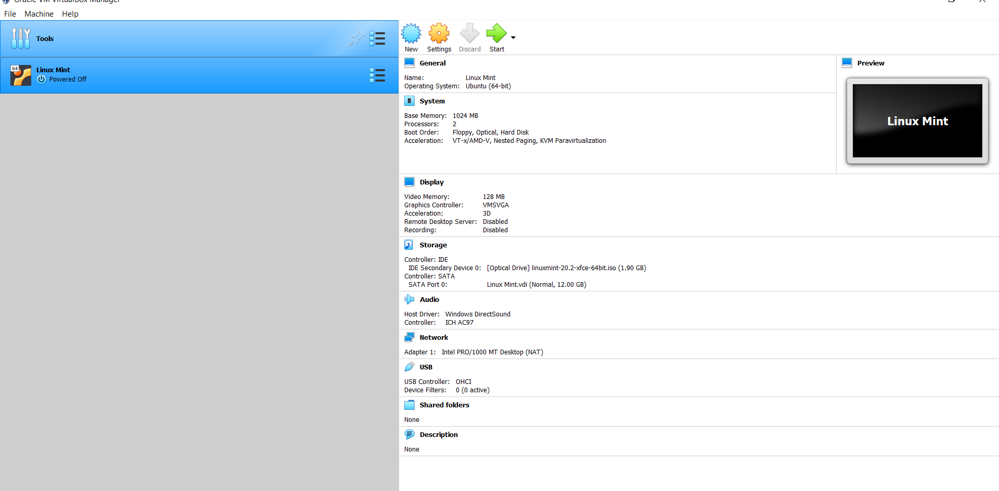

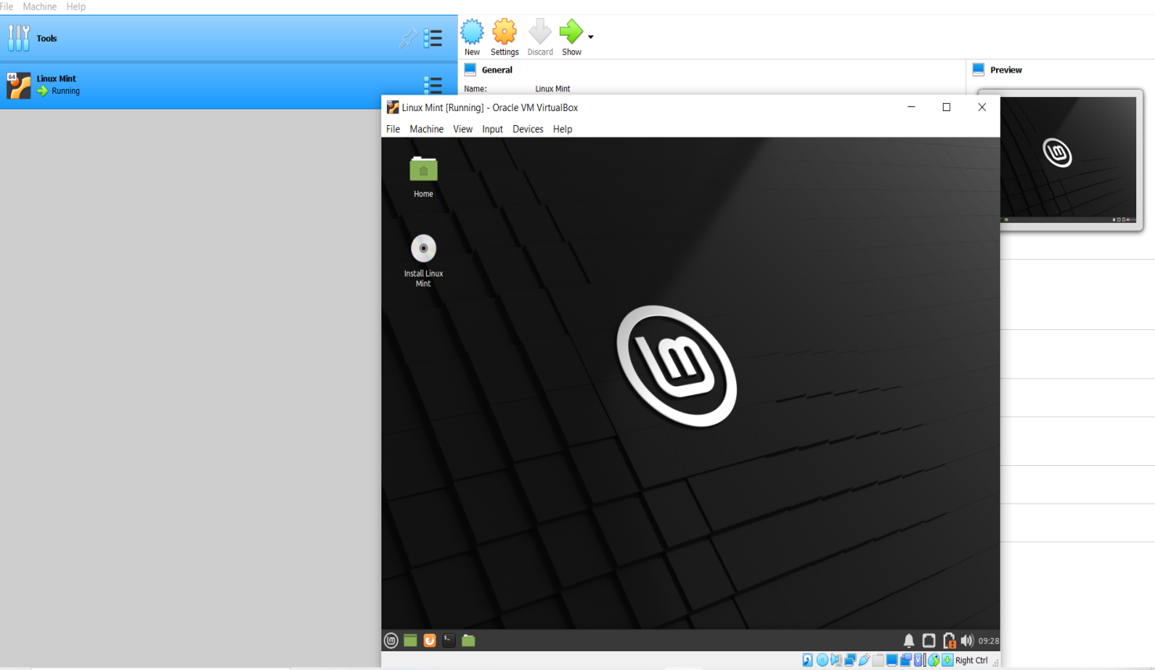

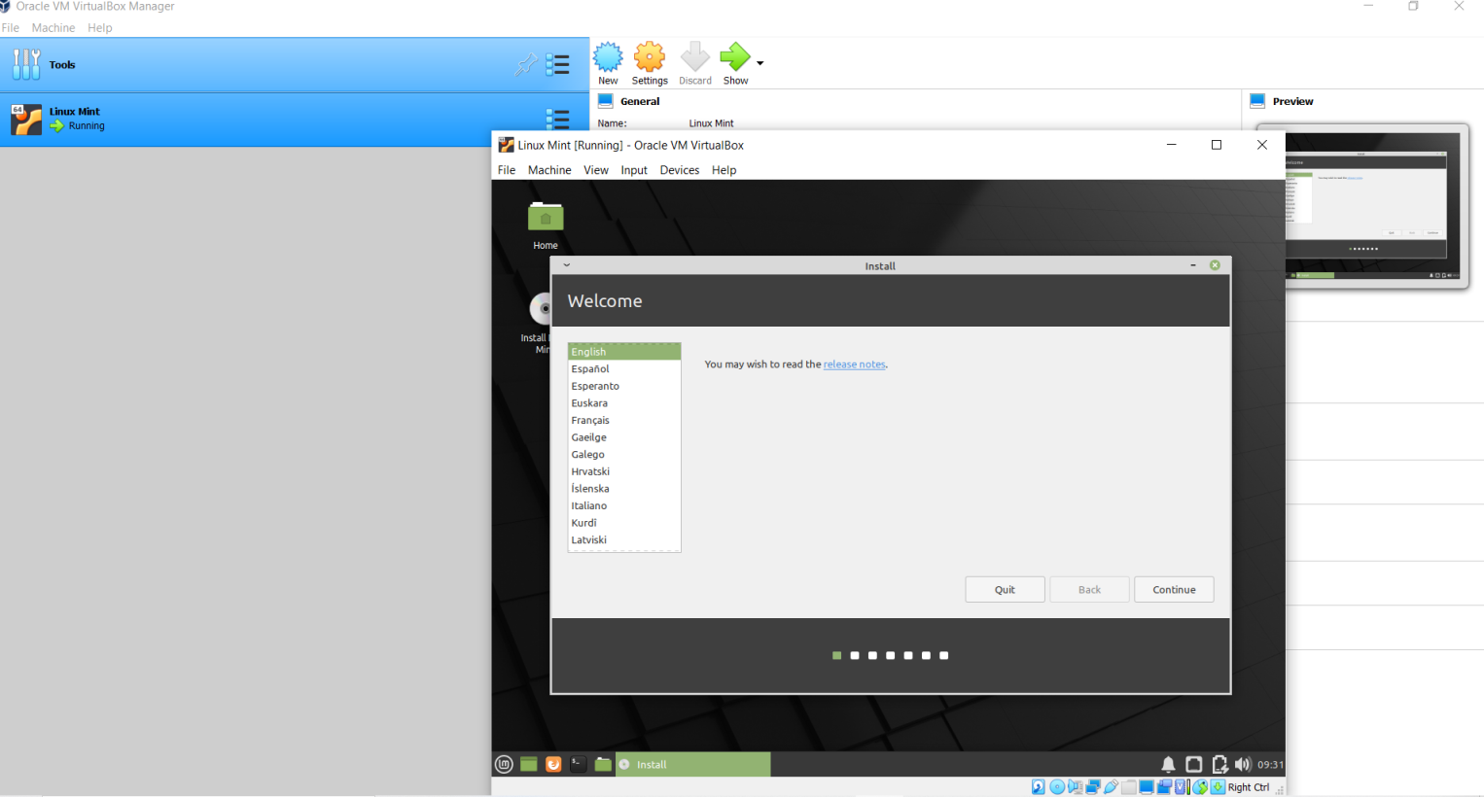

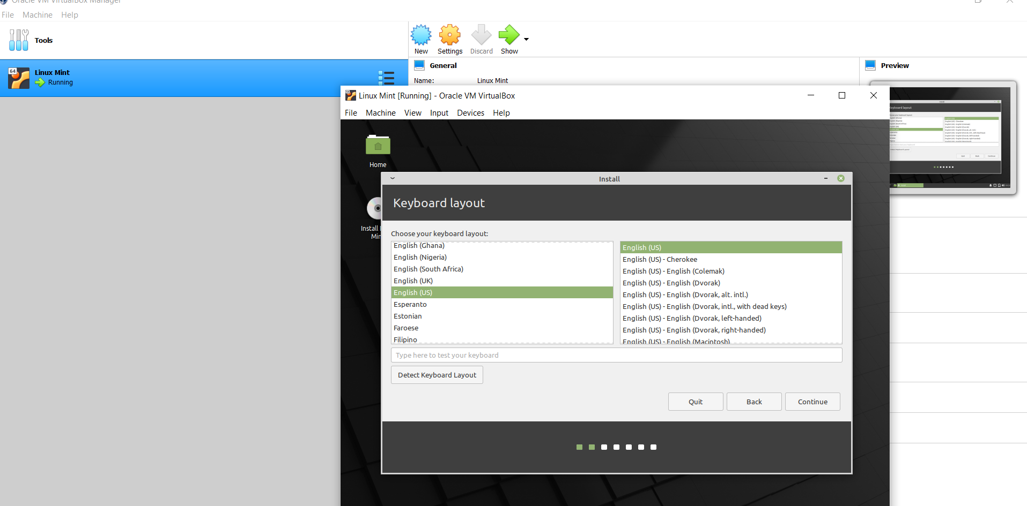

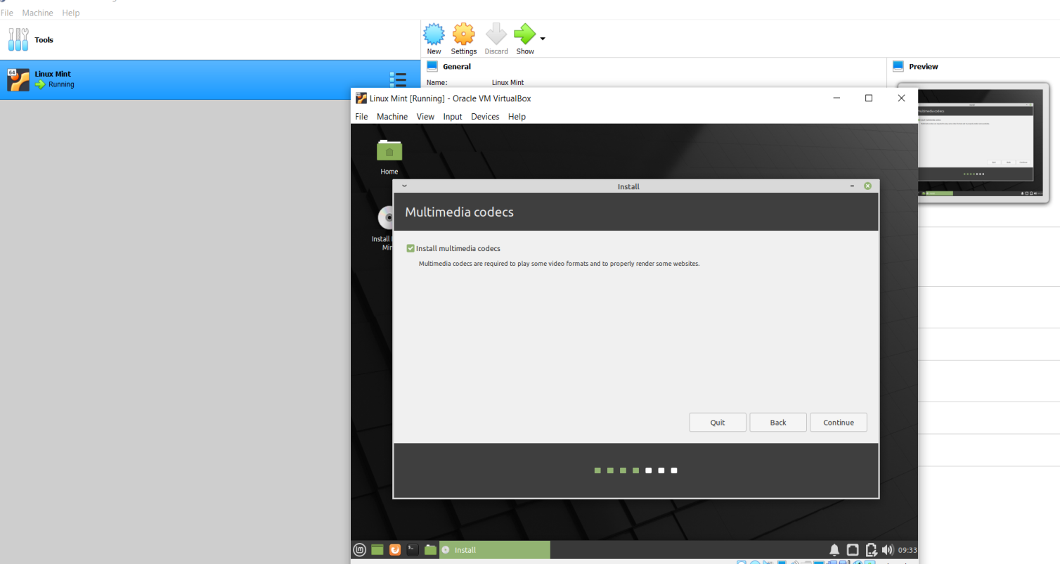

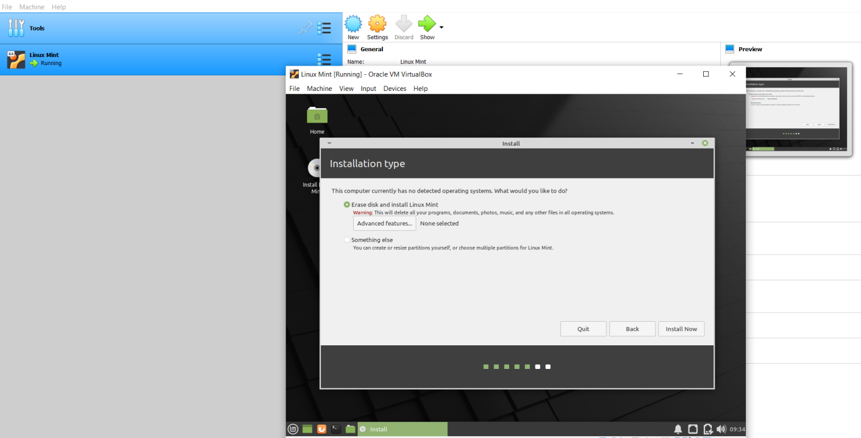

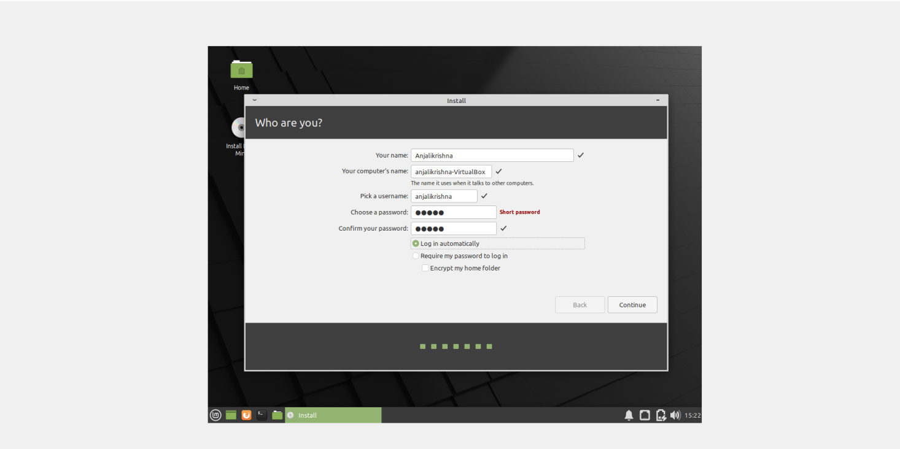

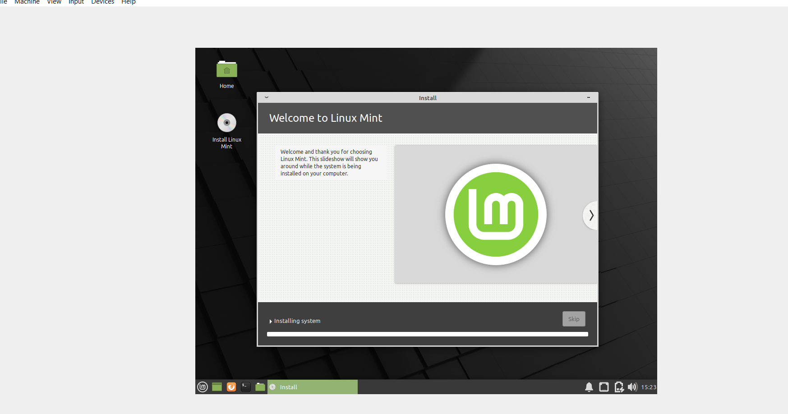

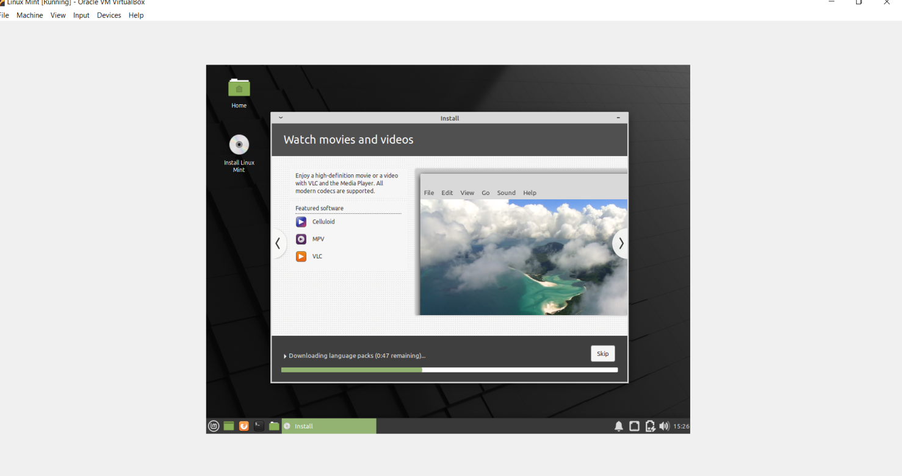

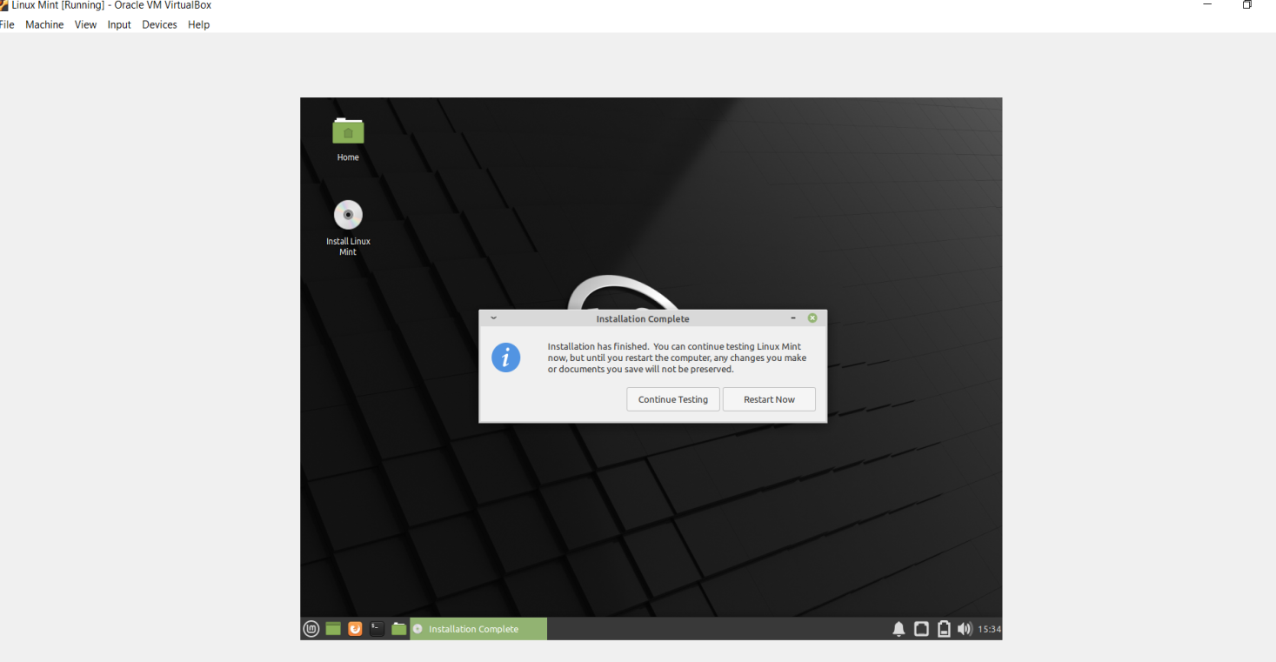

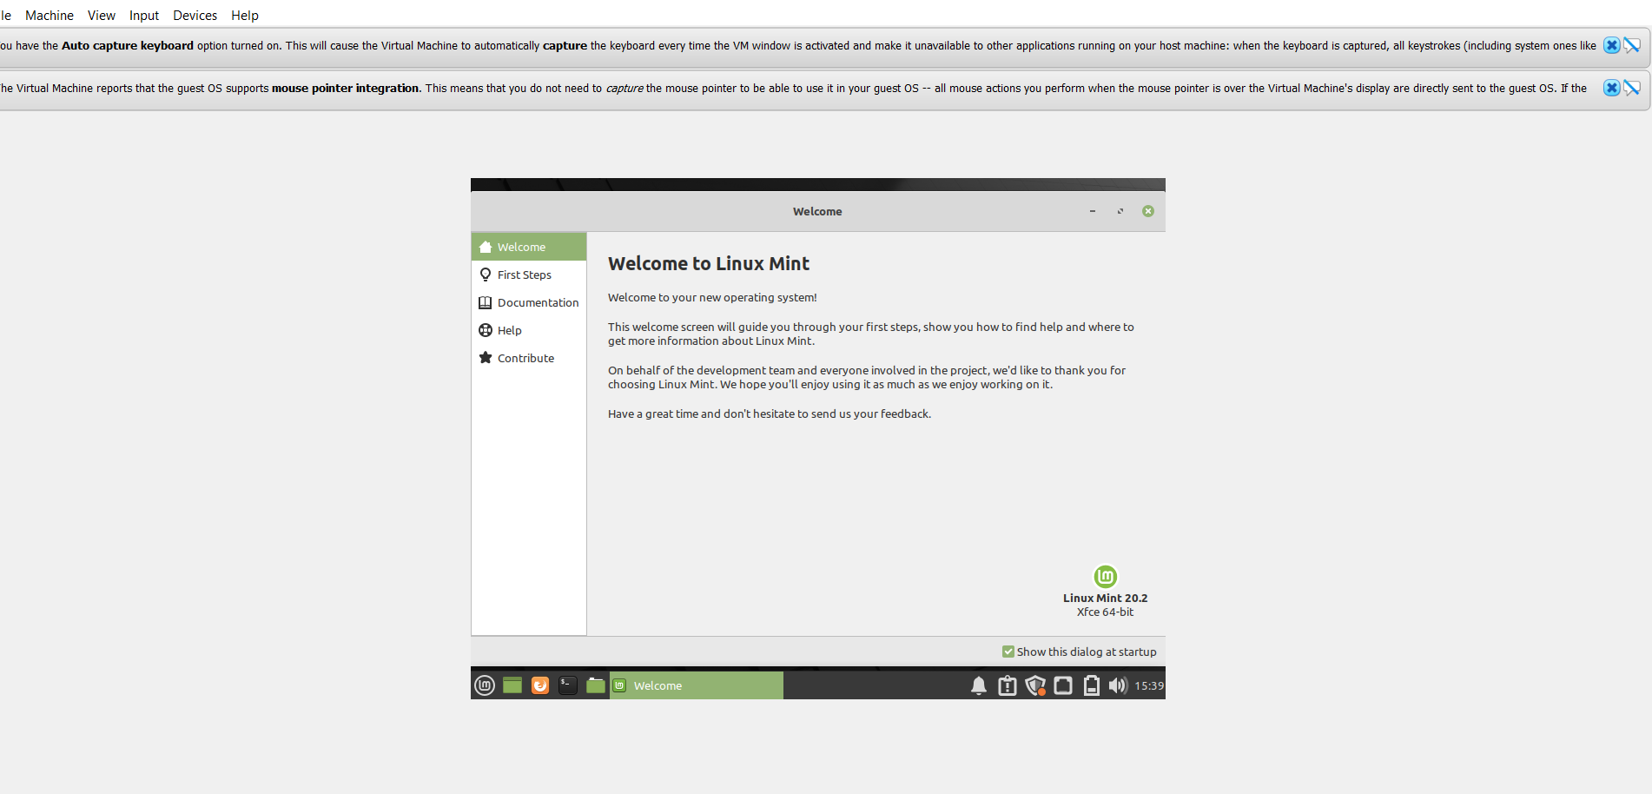

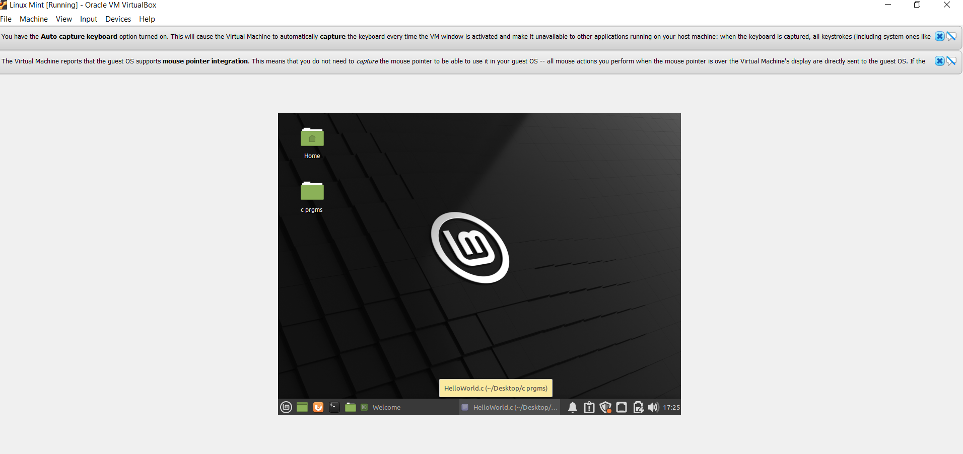

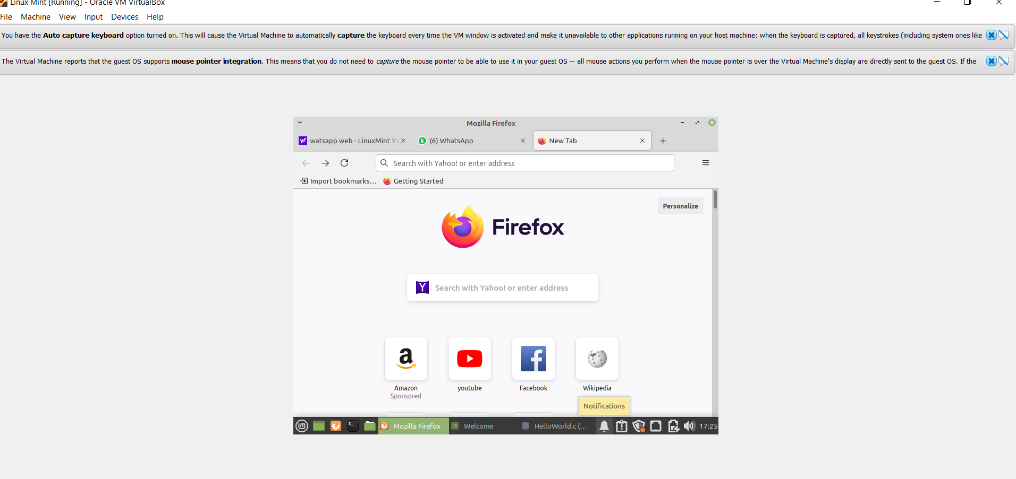

INSTALLING GCC COMPILER ON LINUX MINT

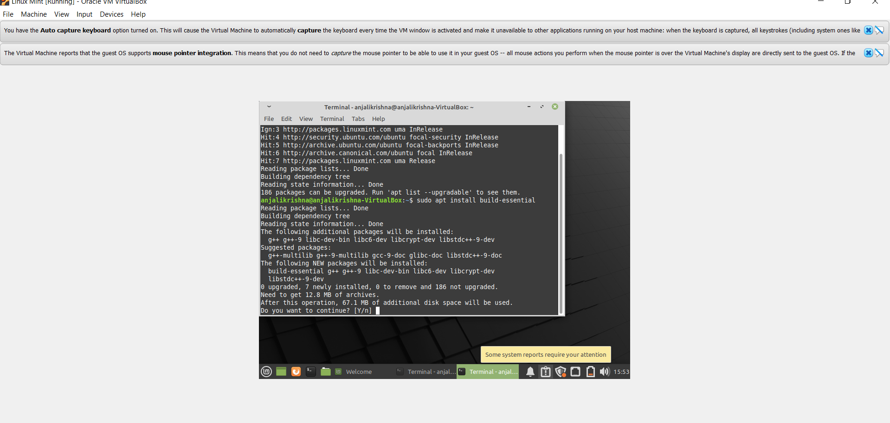

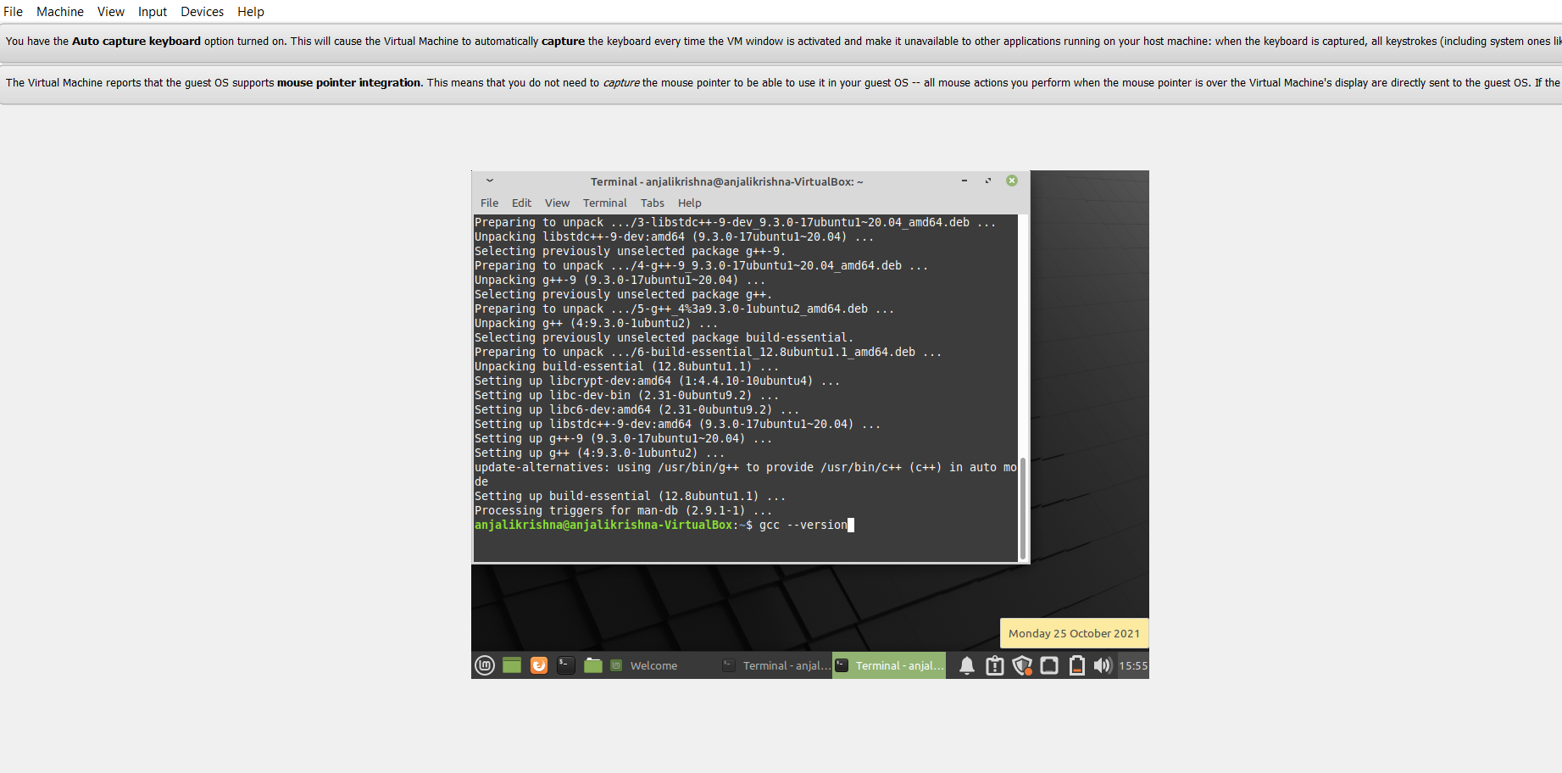

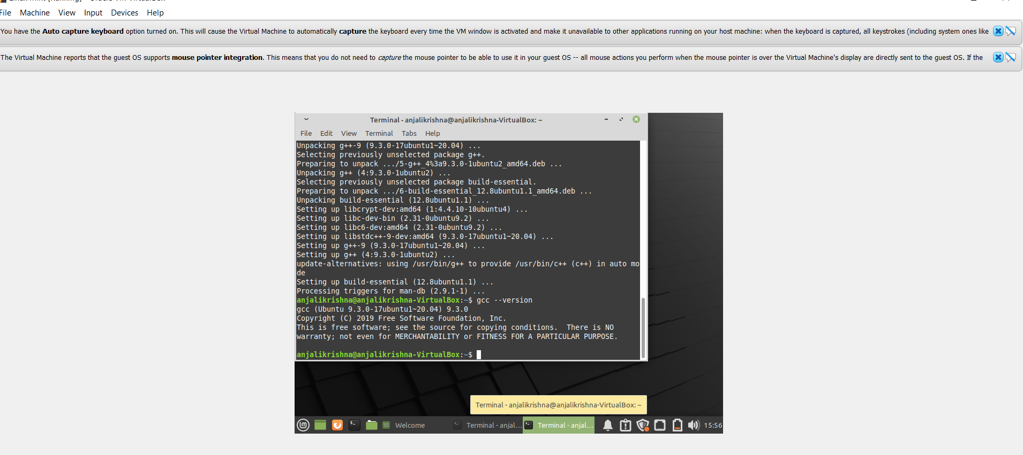

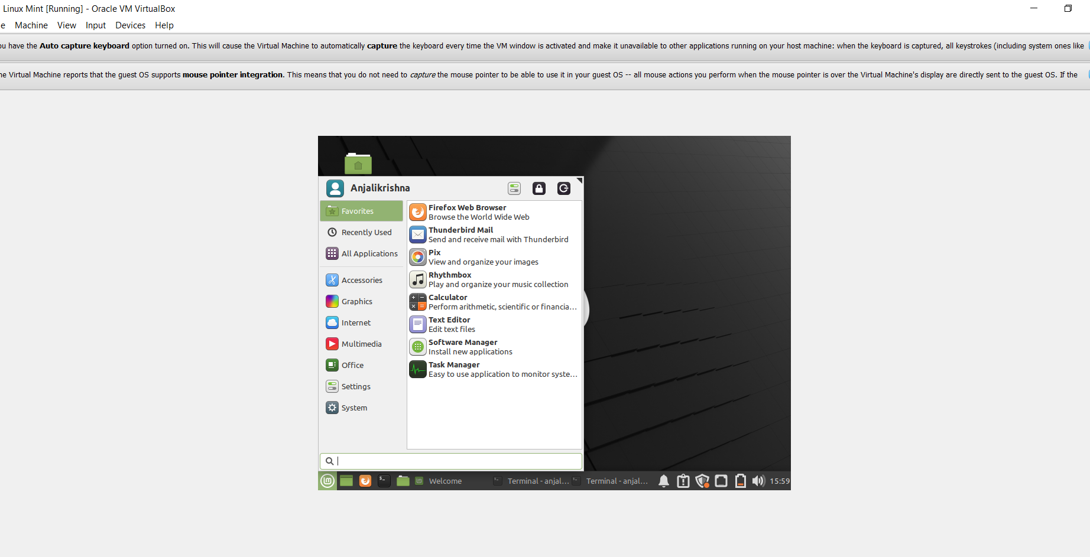

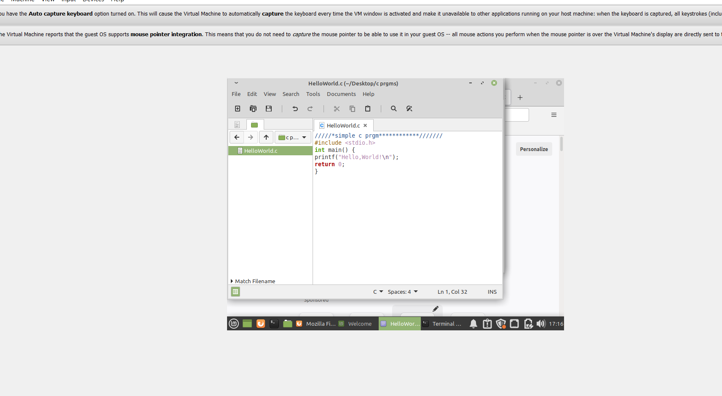

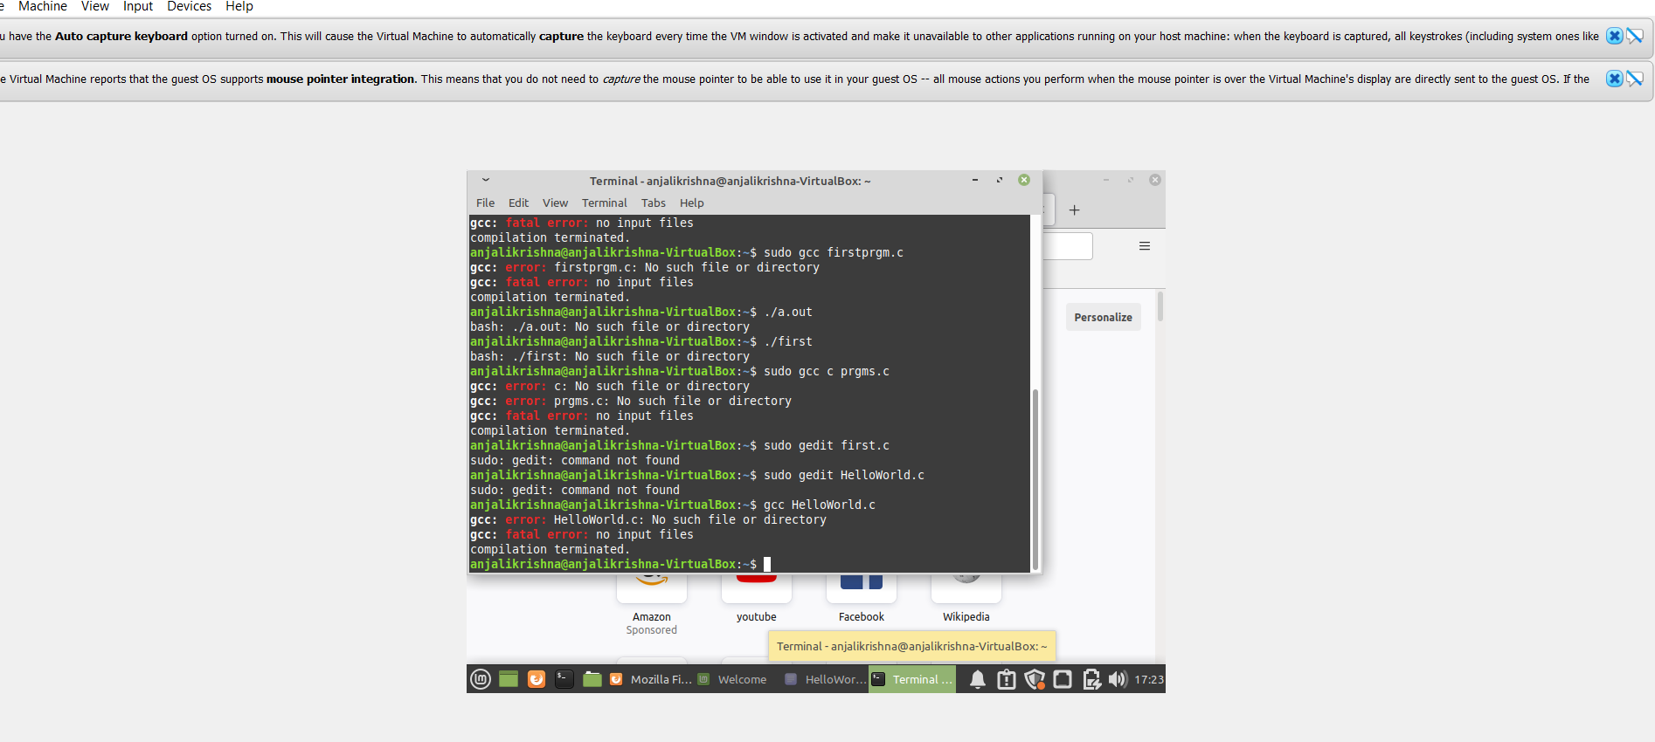

CENTOS 8 INSTALLATION PROCESS

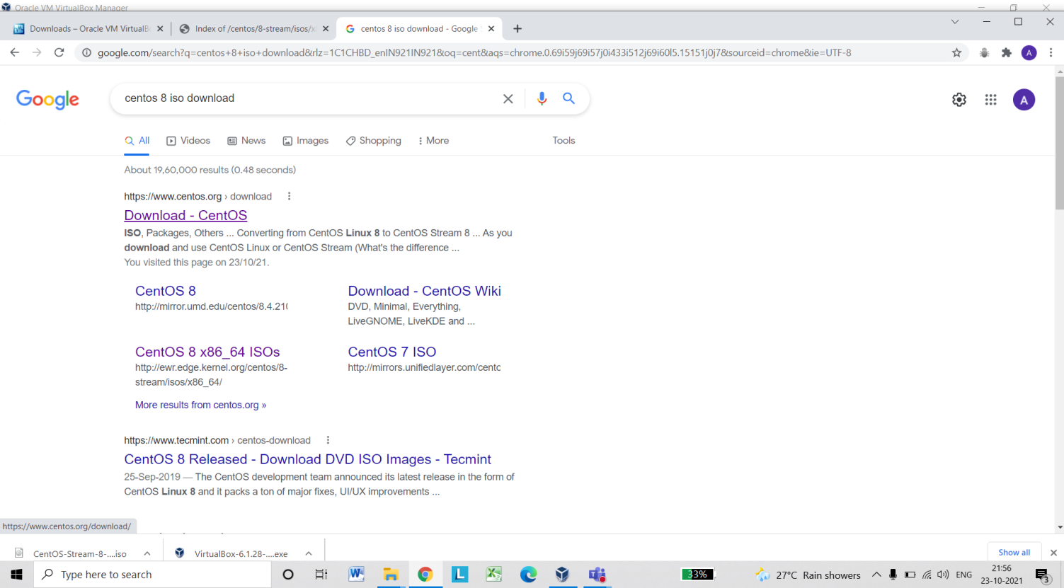

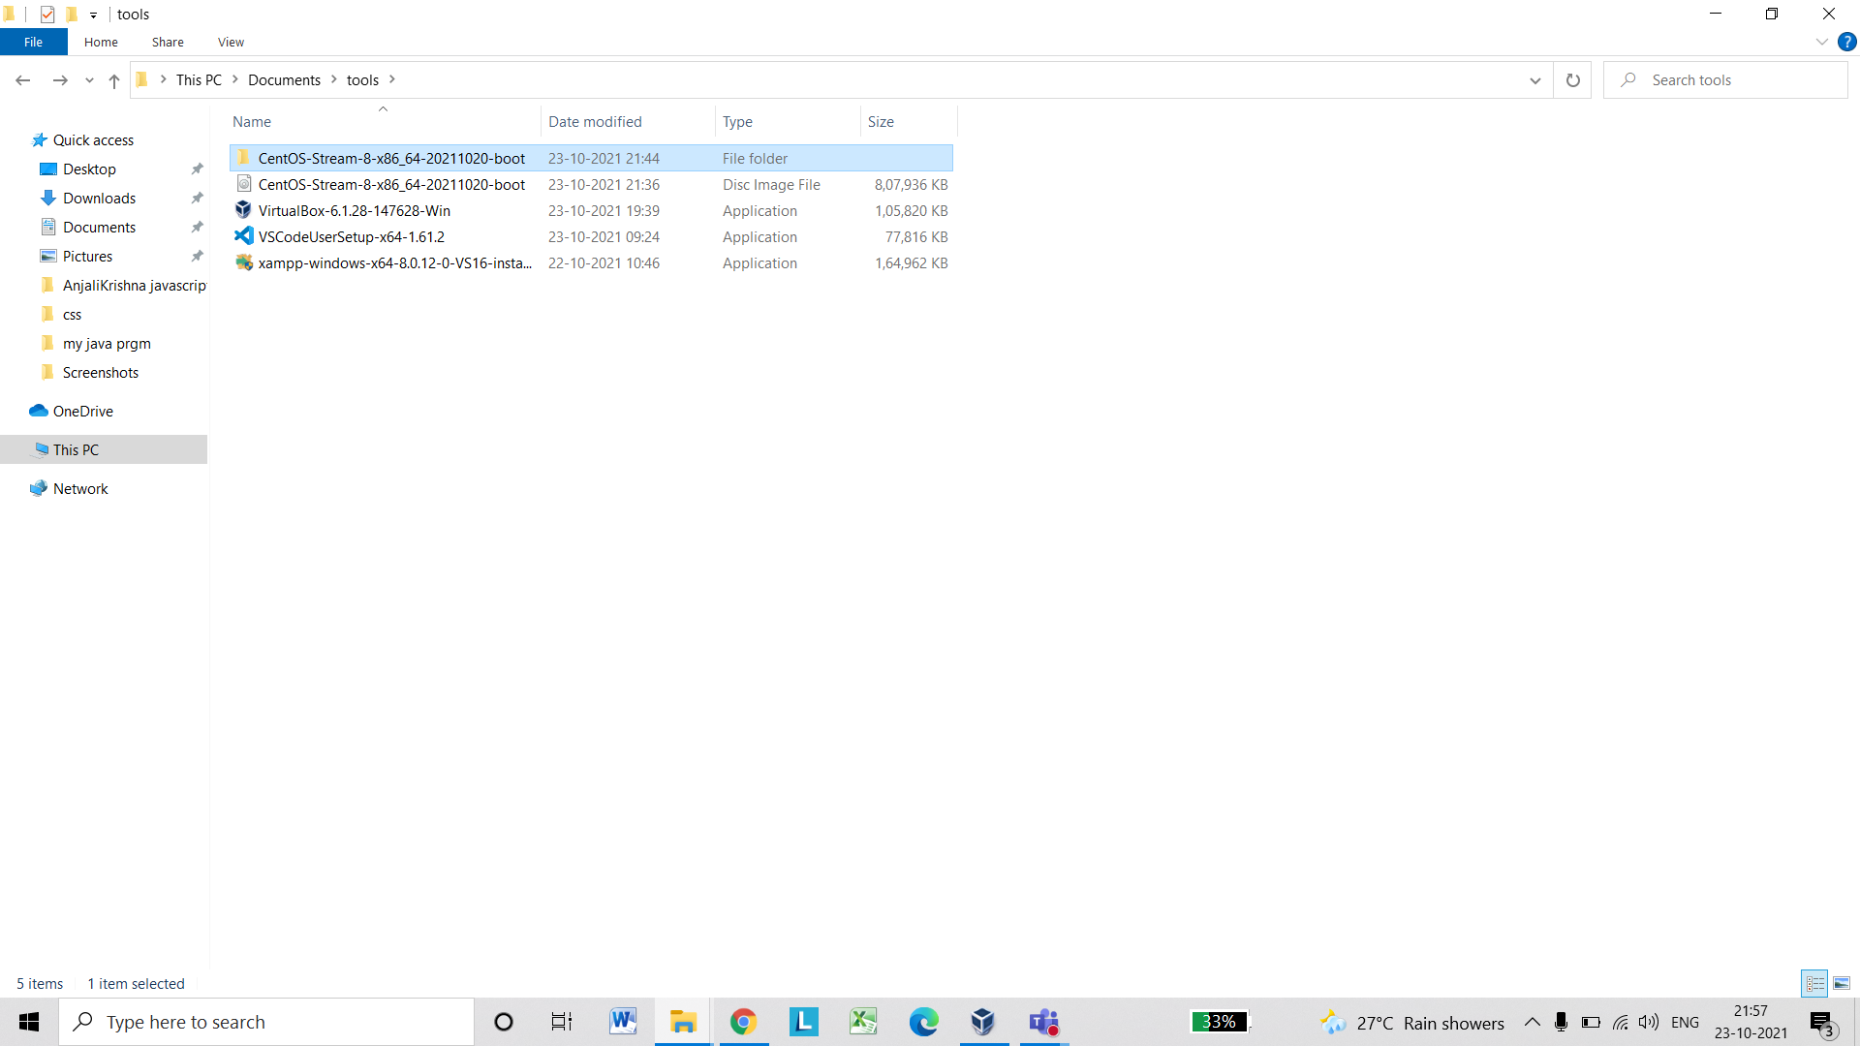

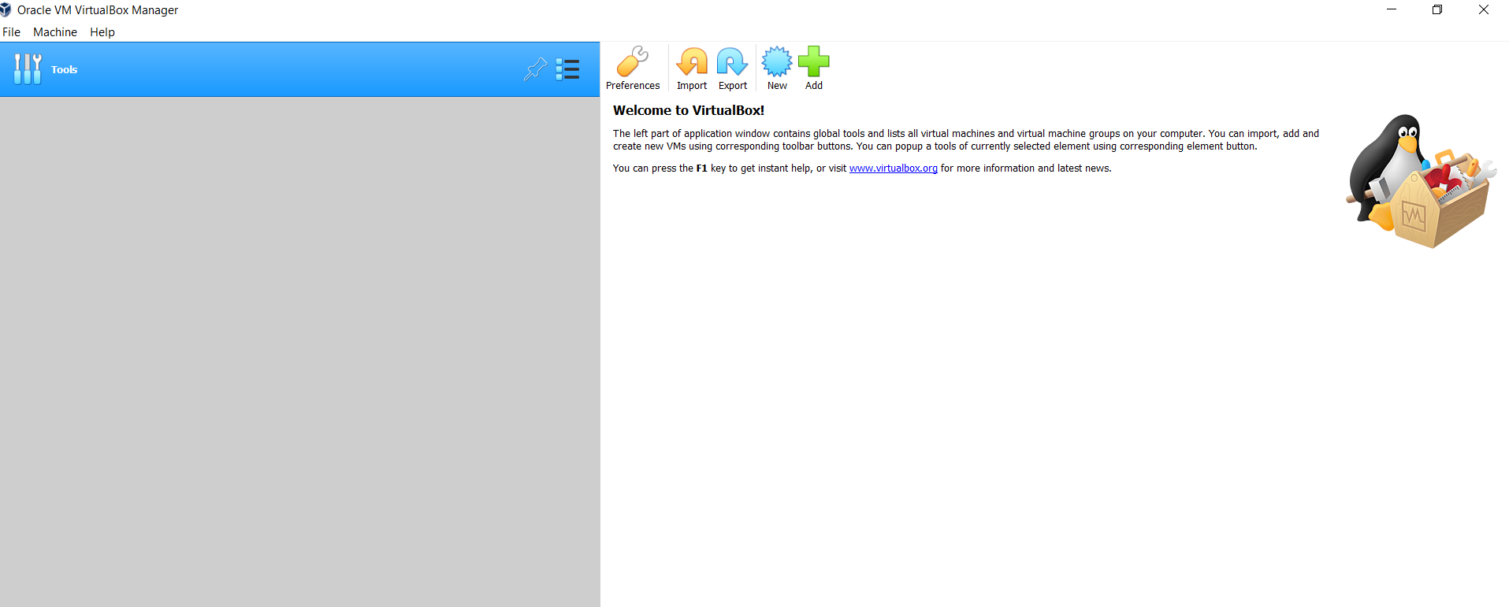

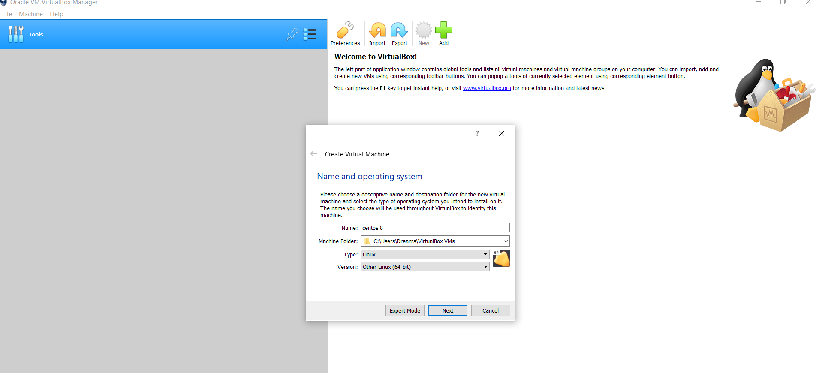

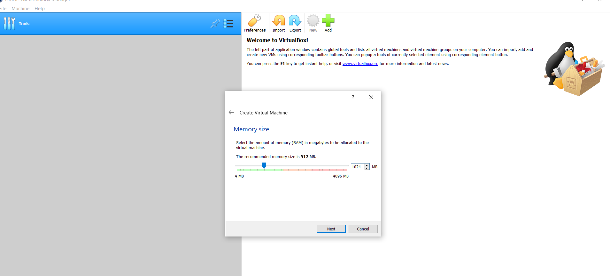

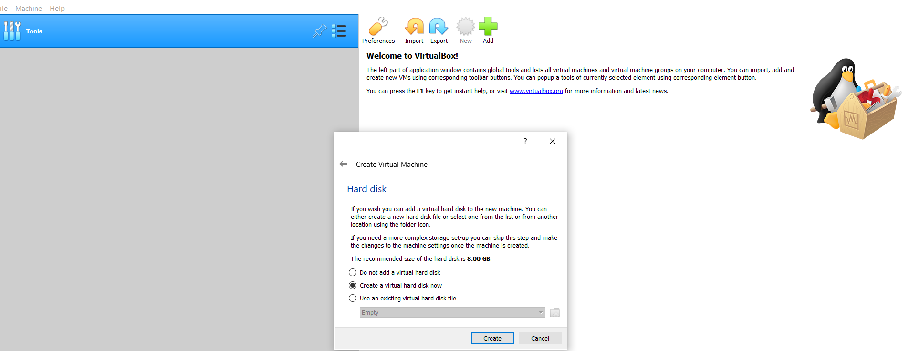

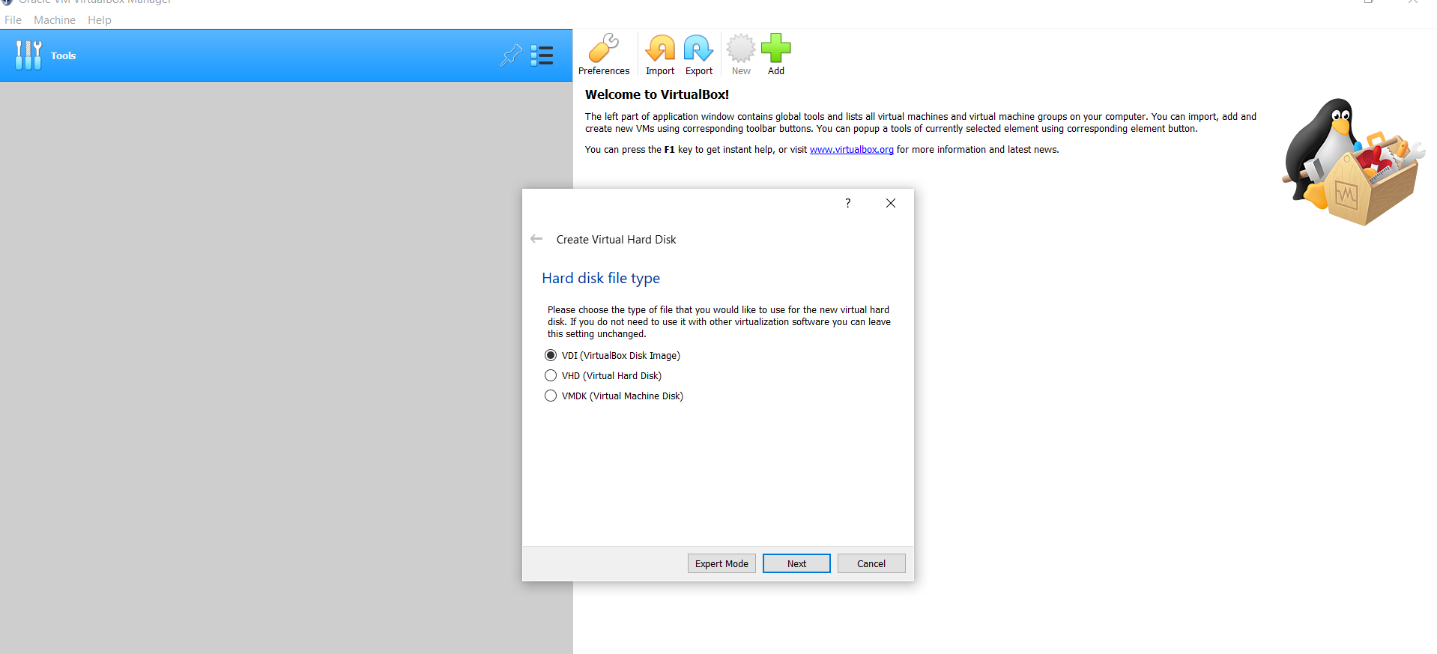

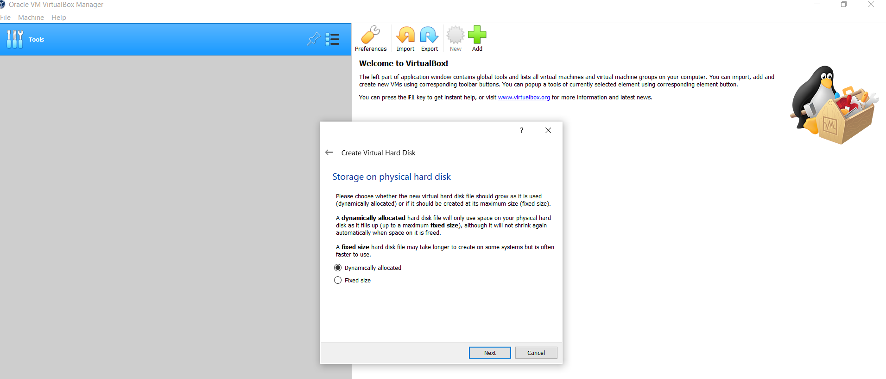

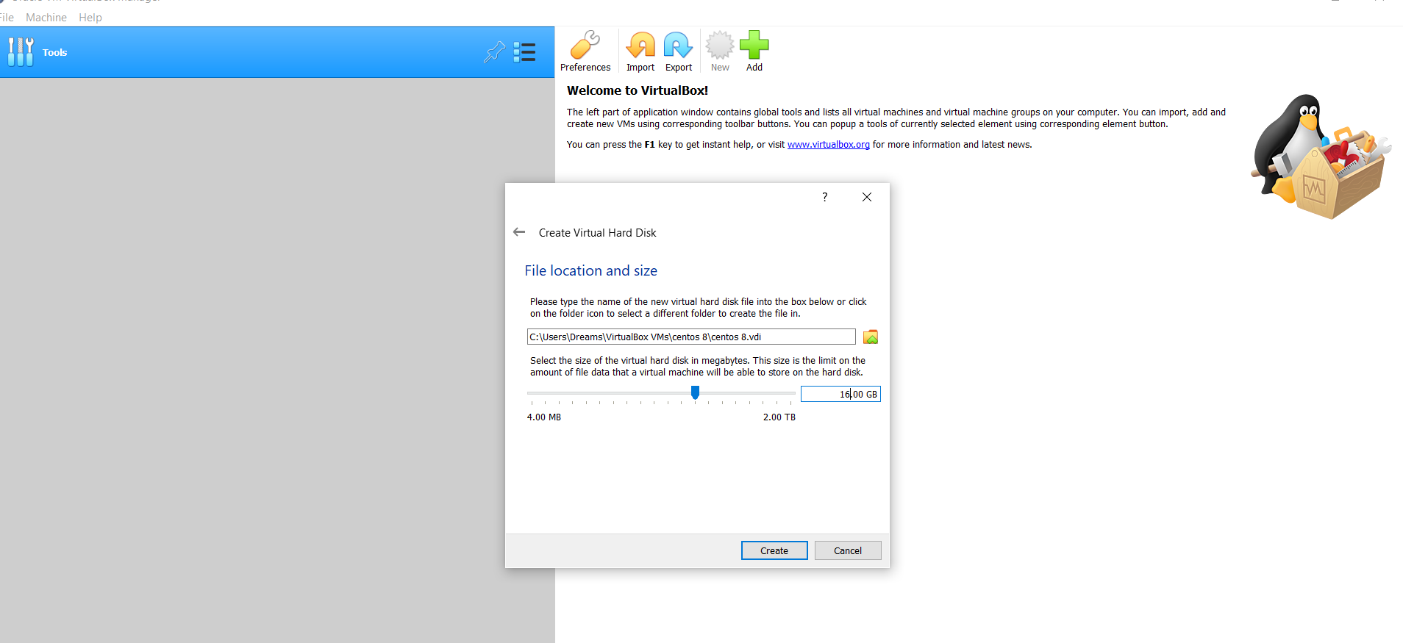

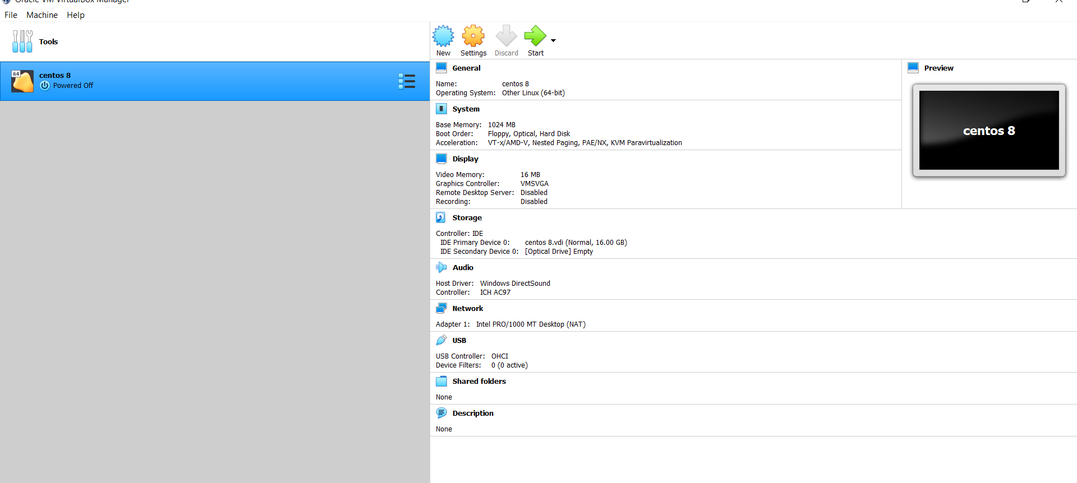

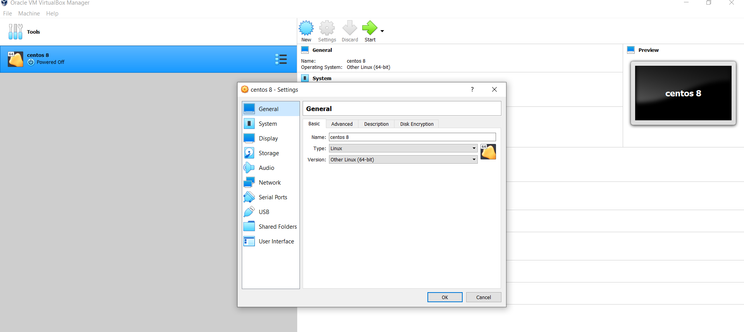



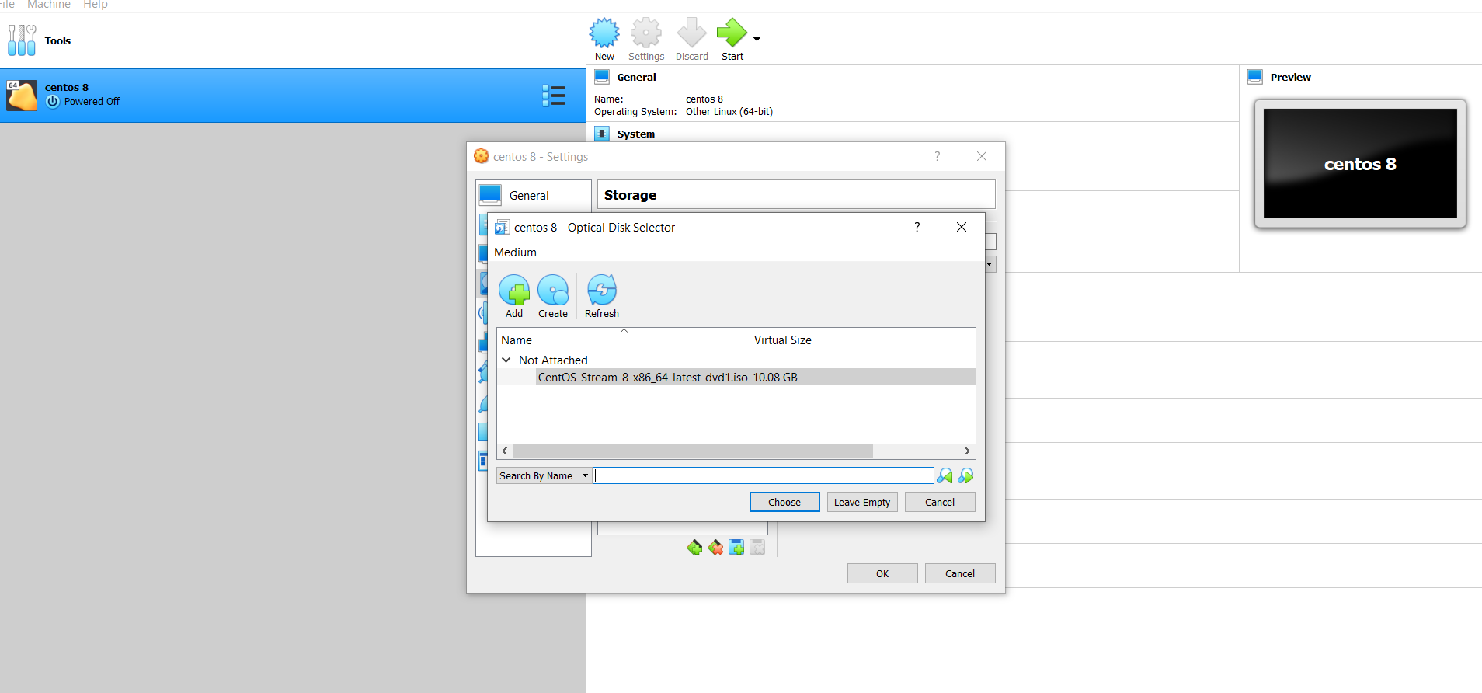

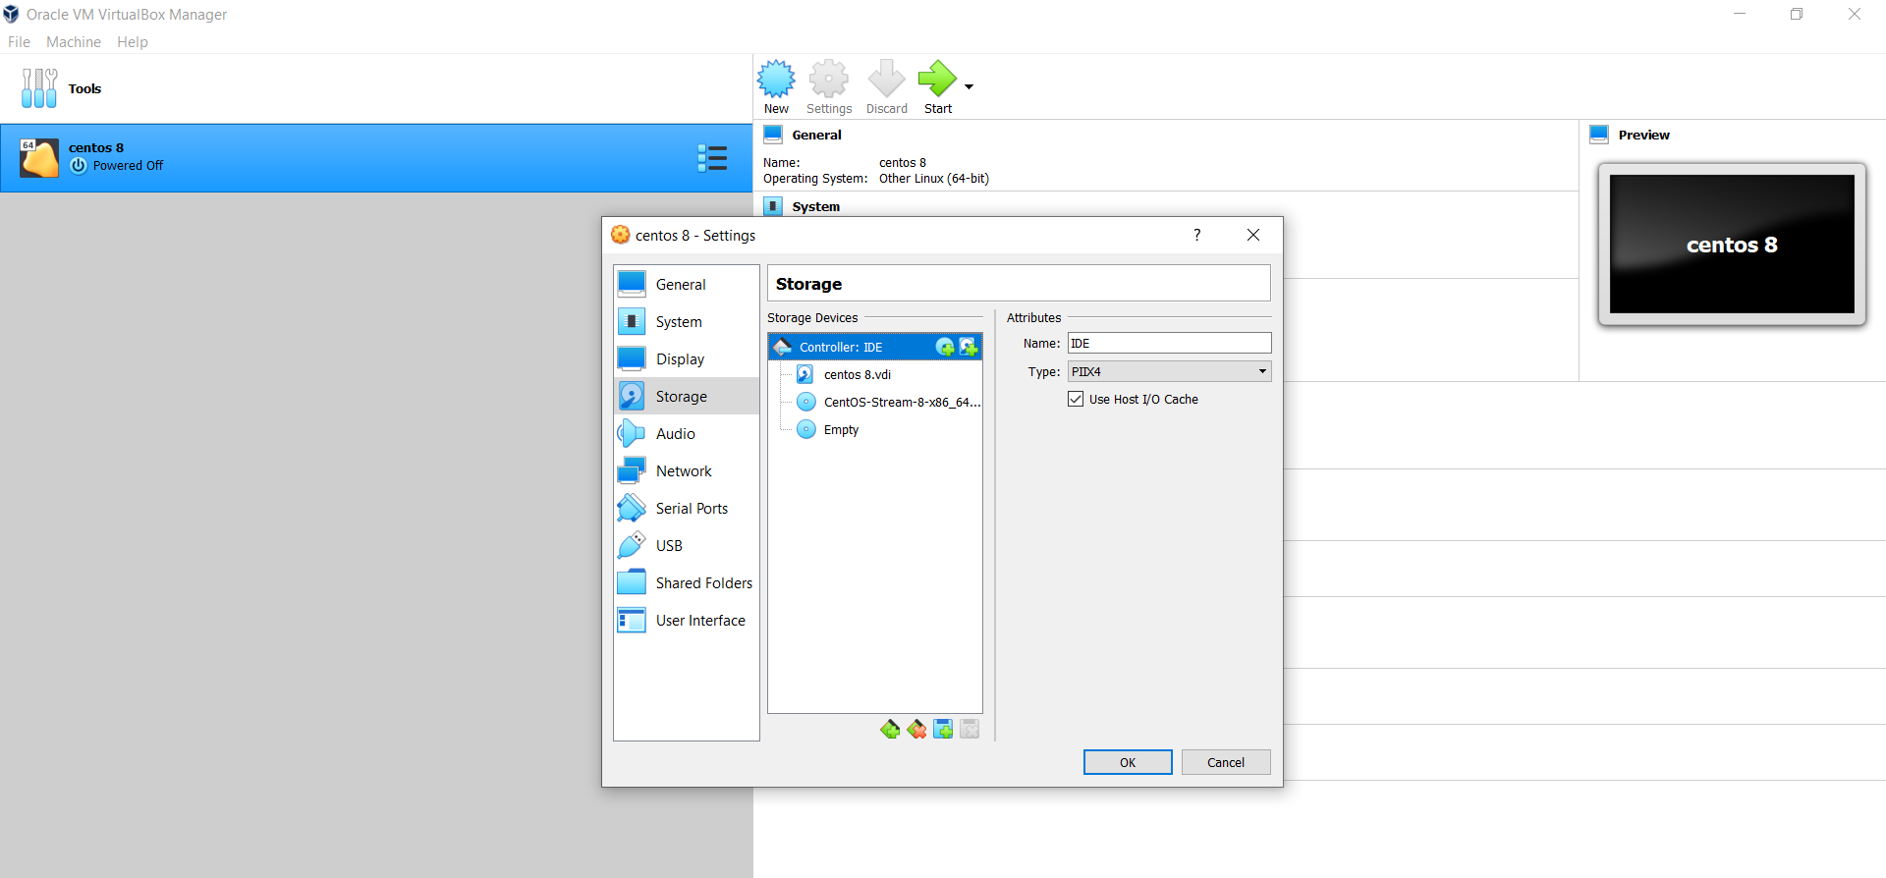

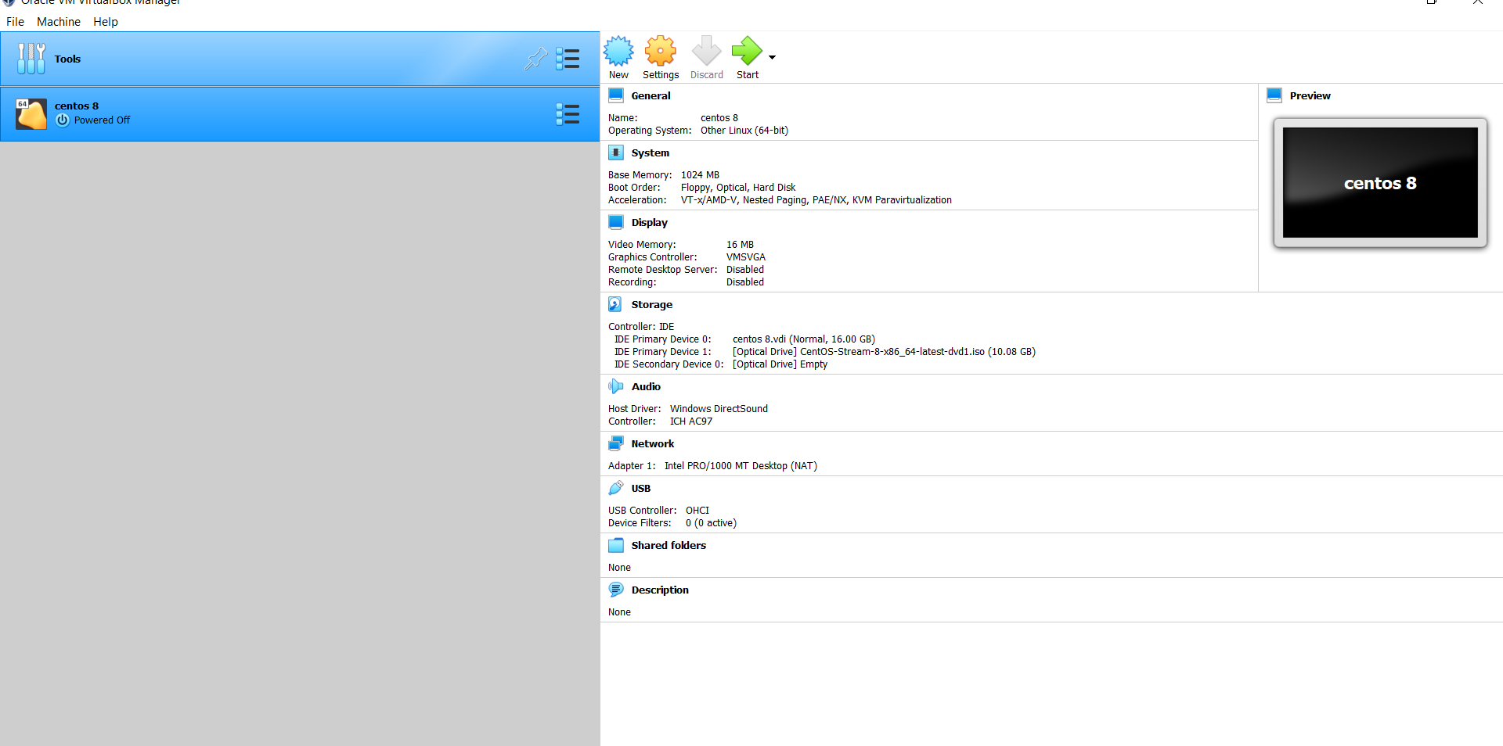

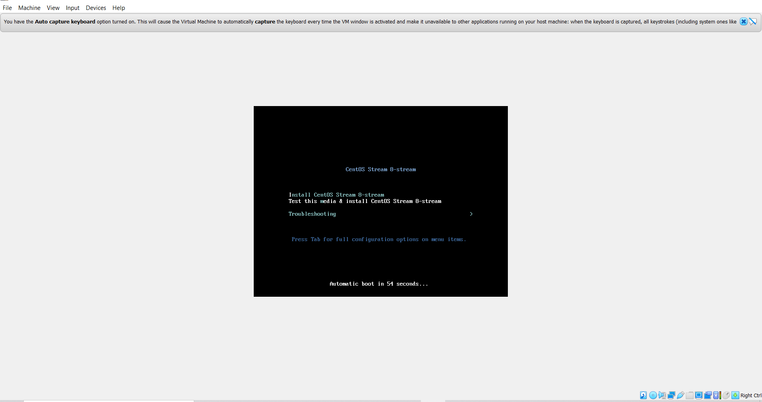



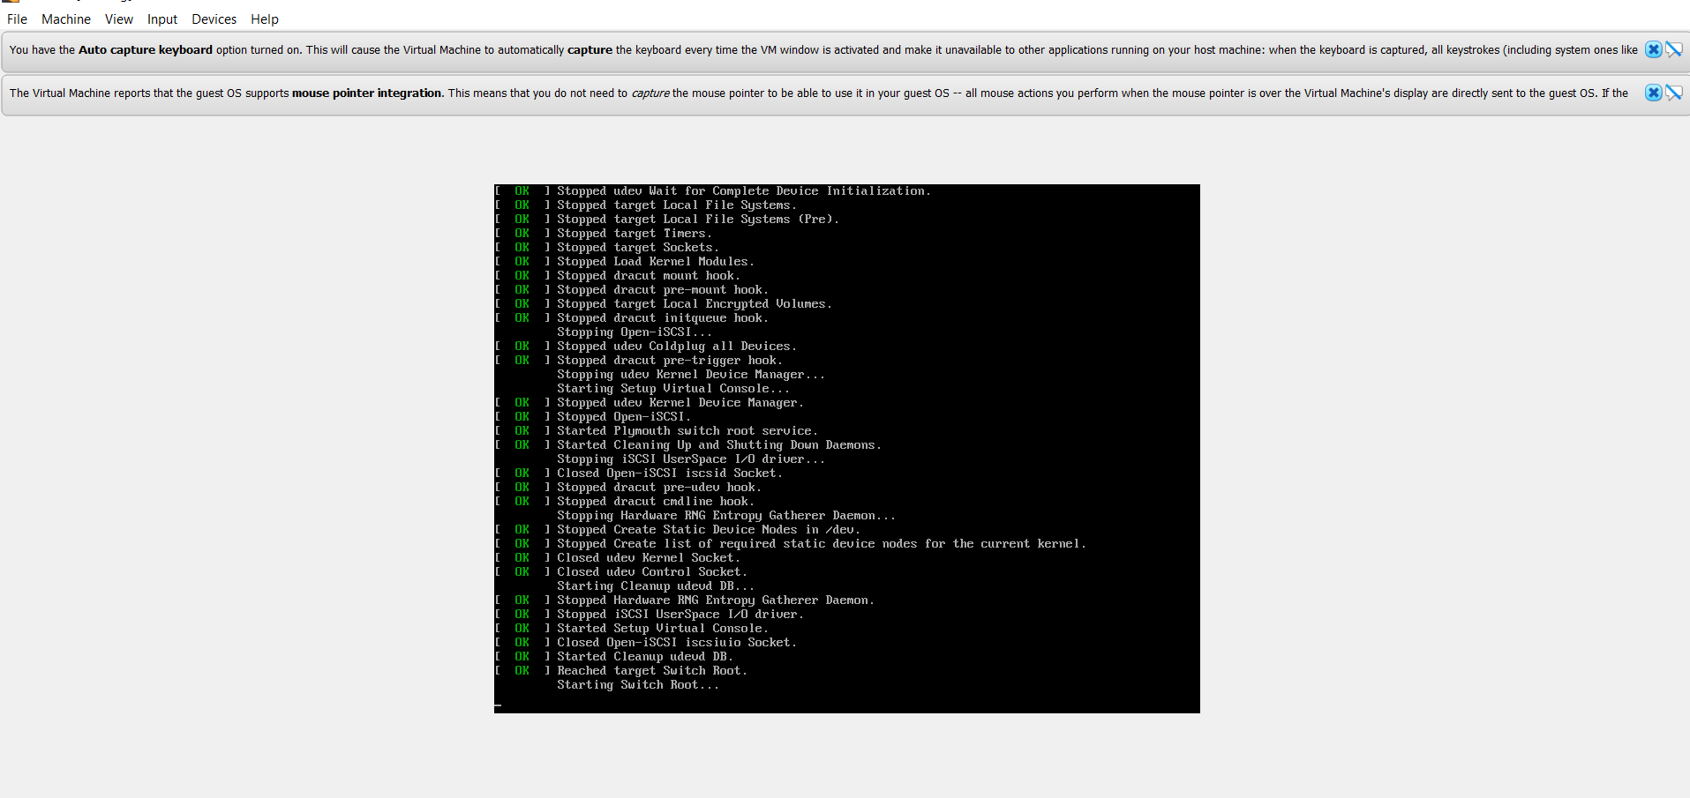

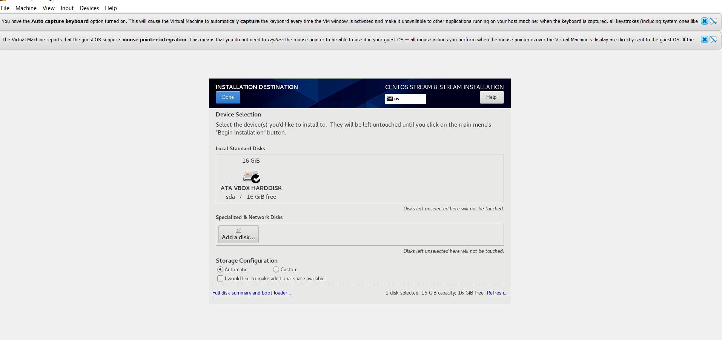

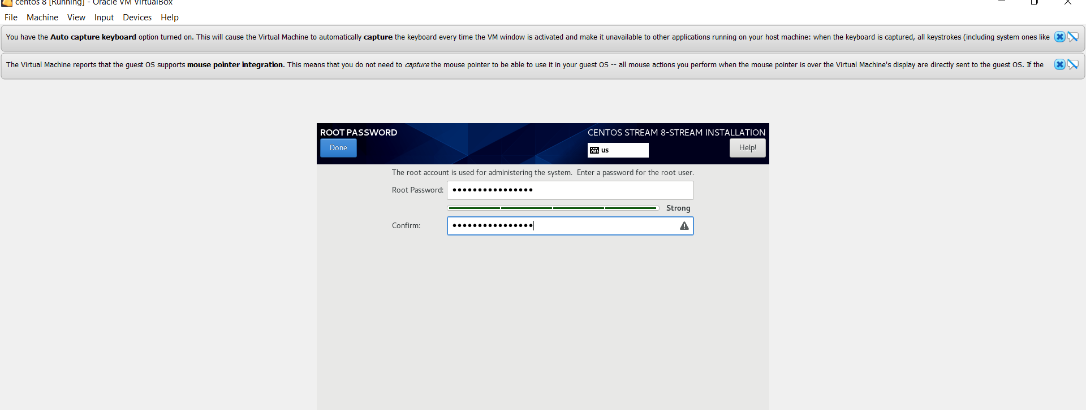

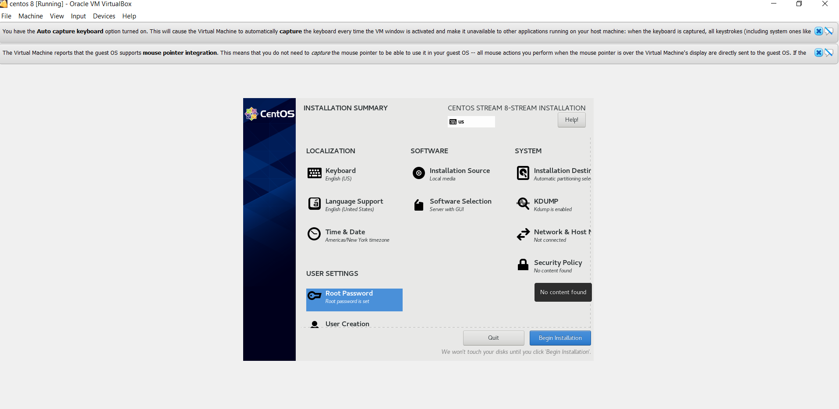

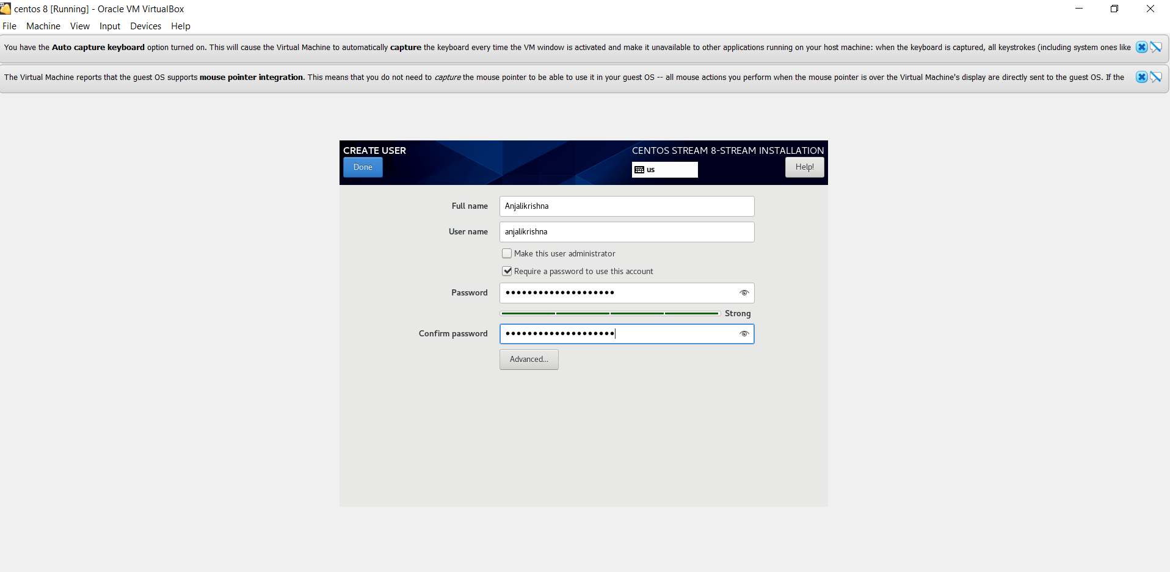



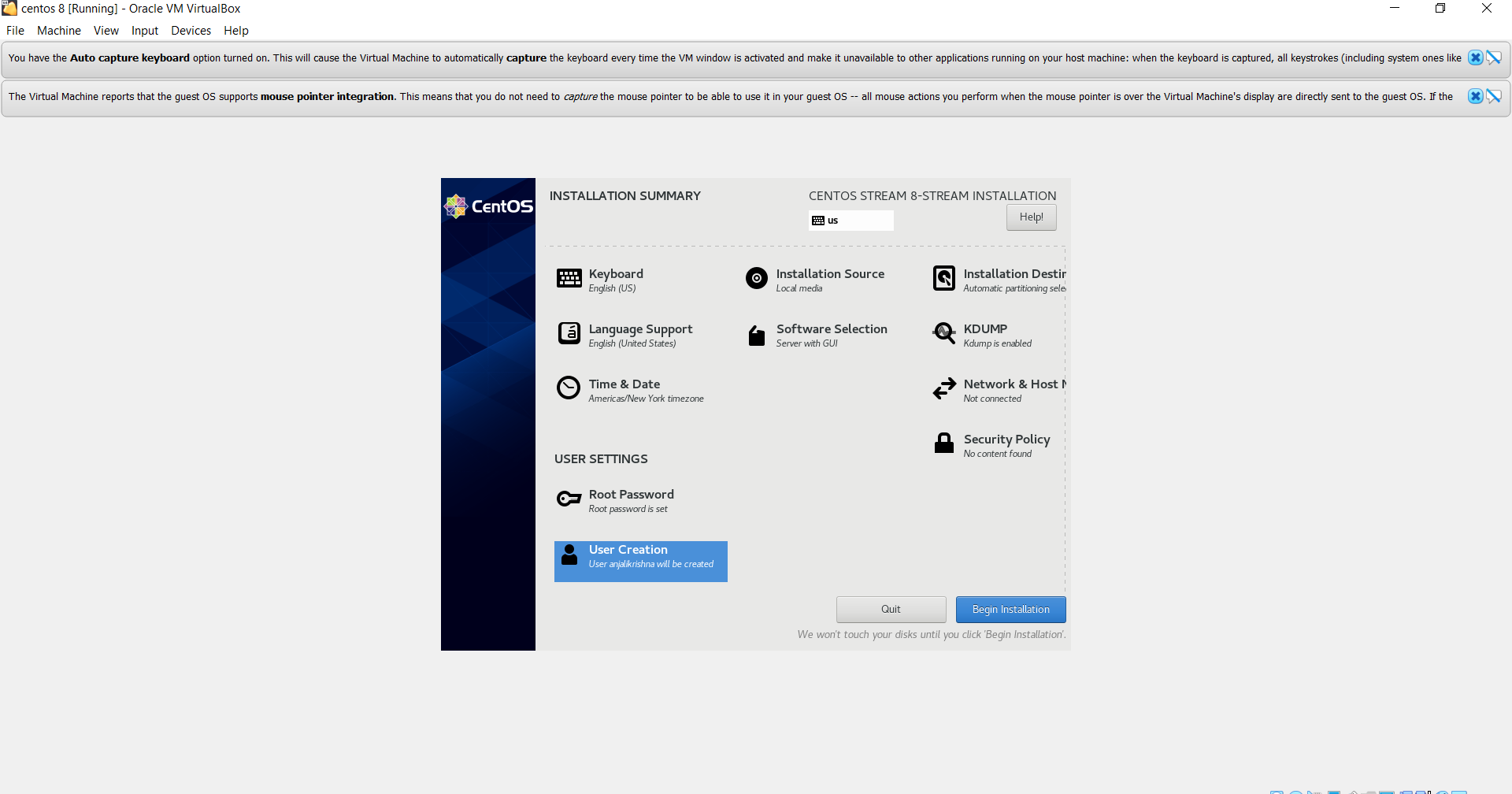

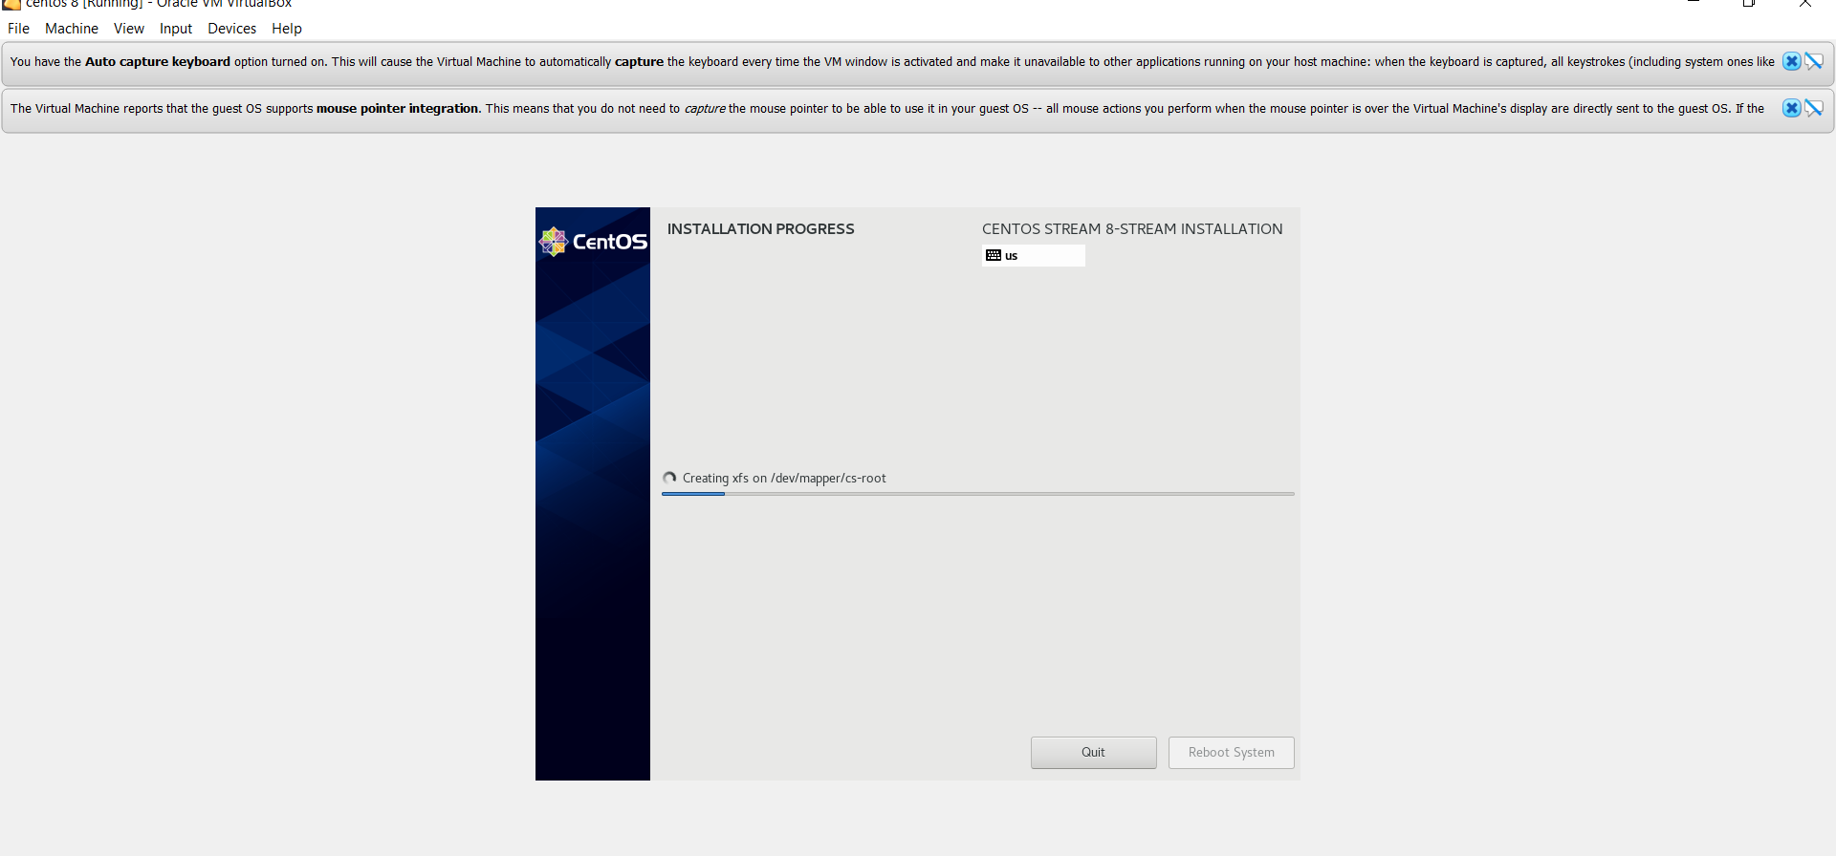

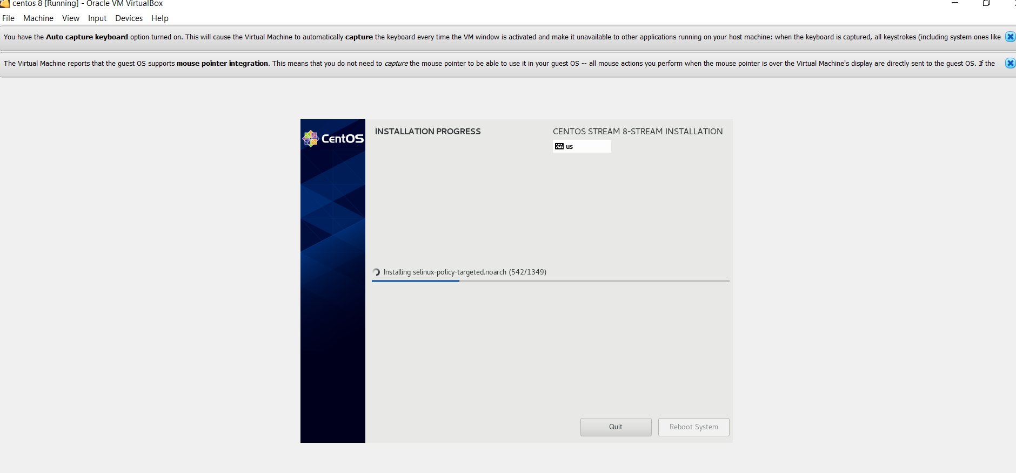

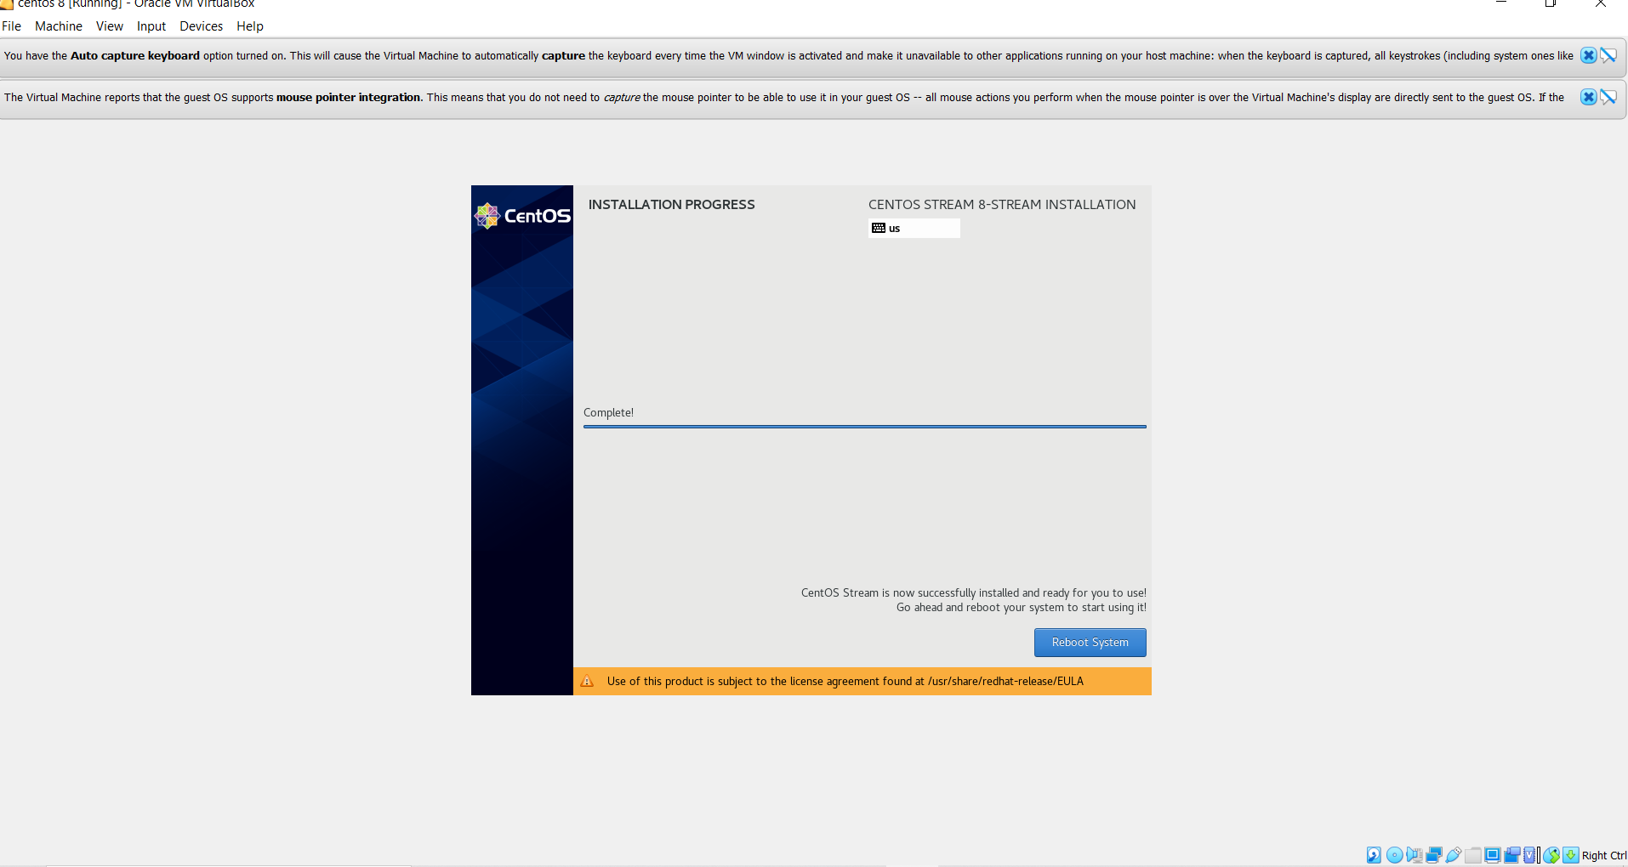

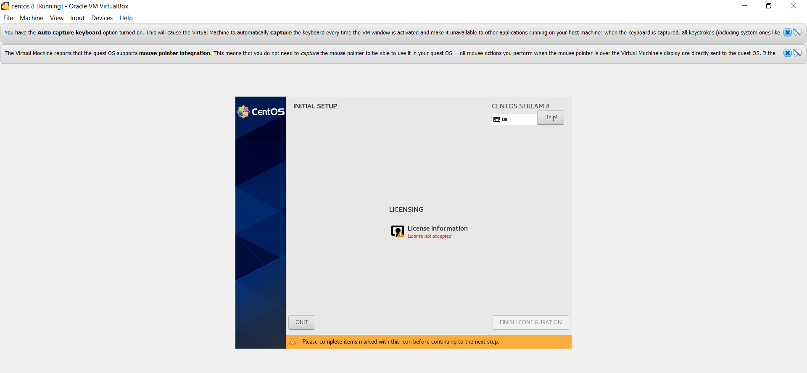

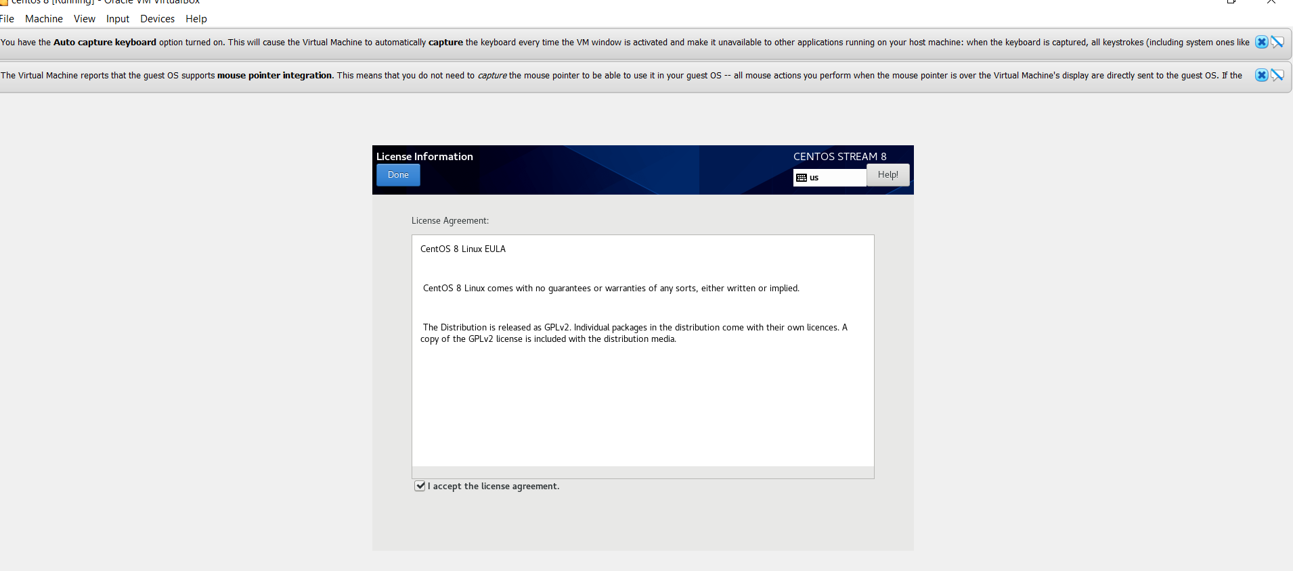

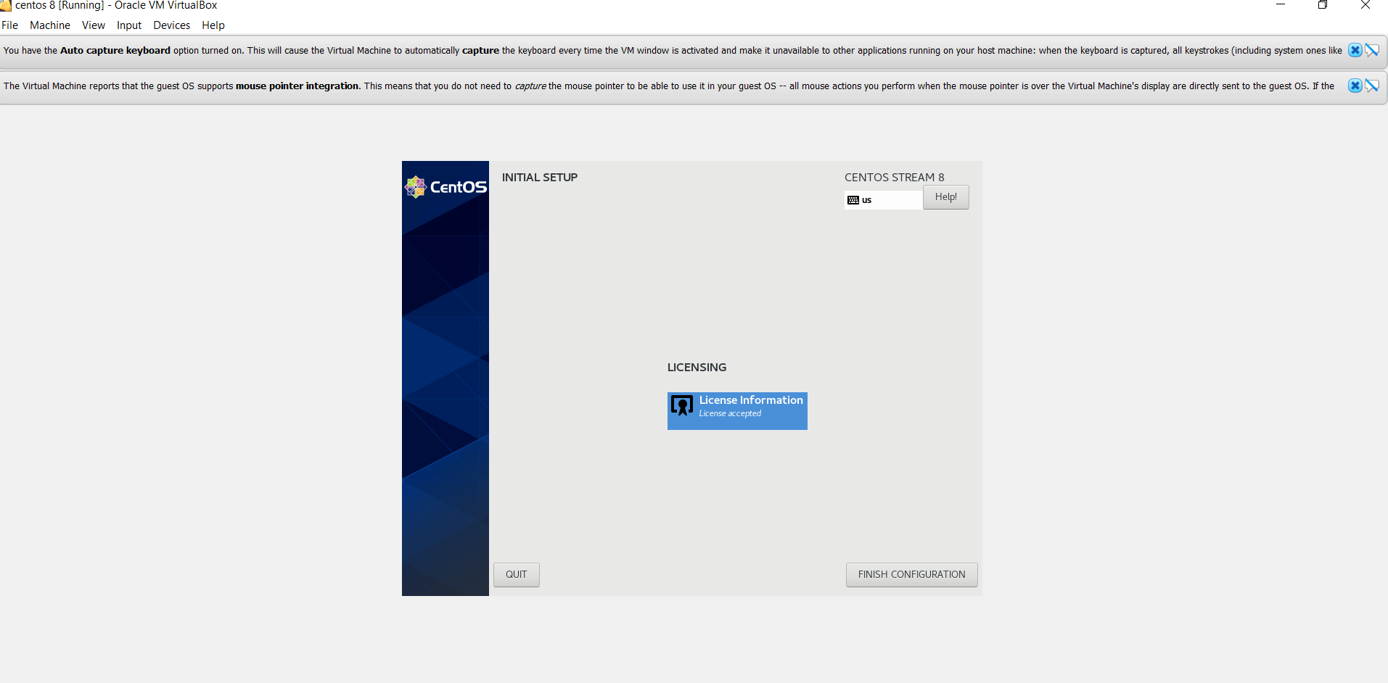

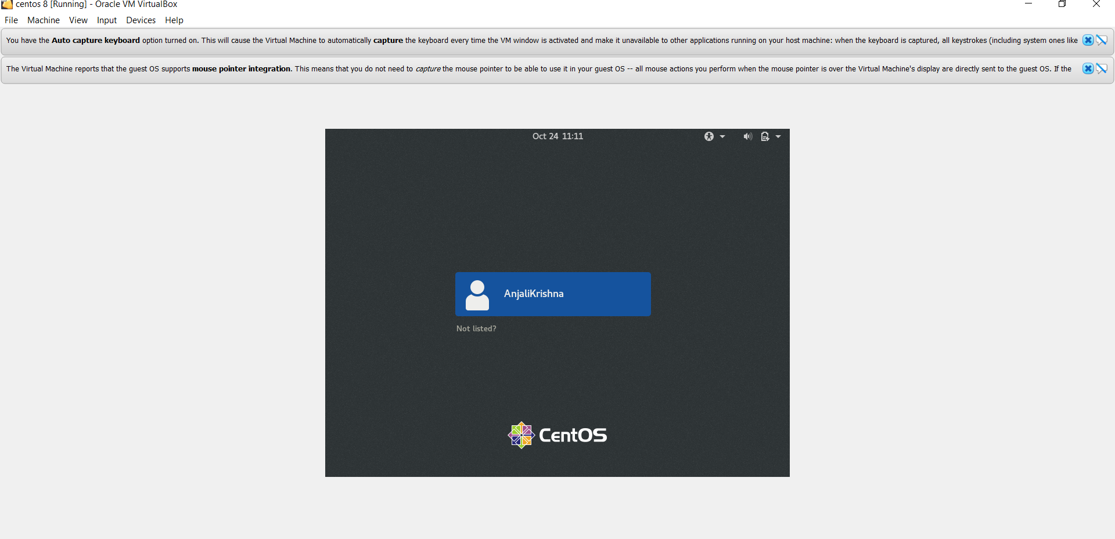

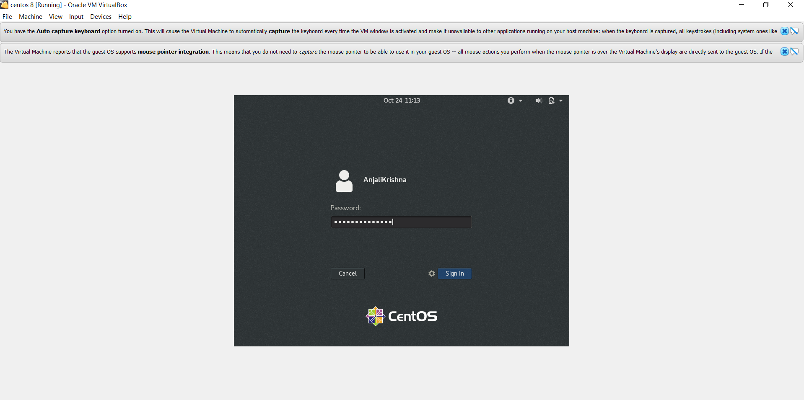

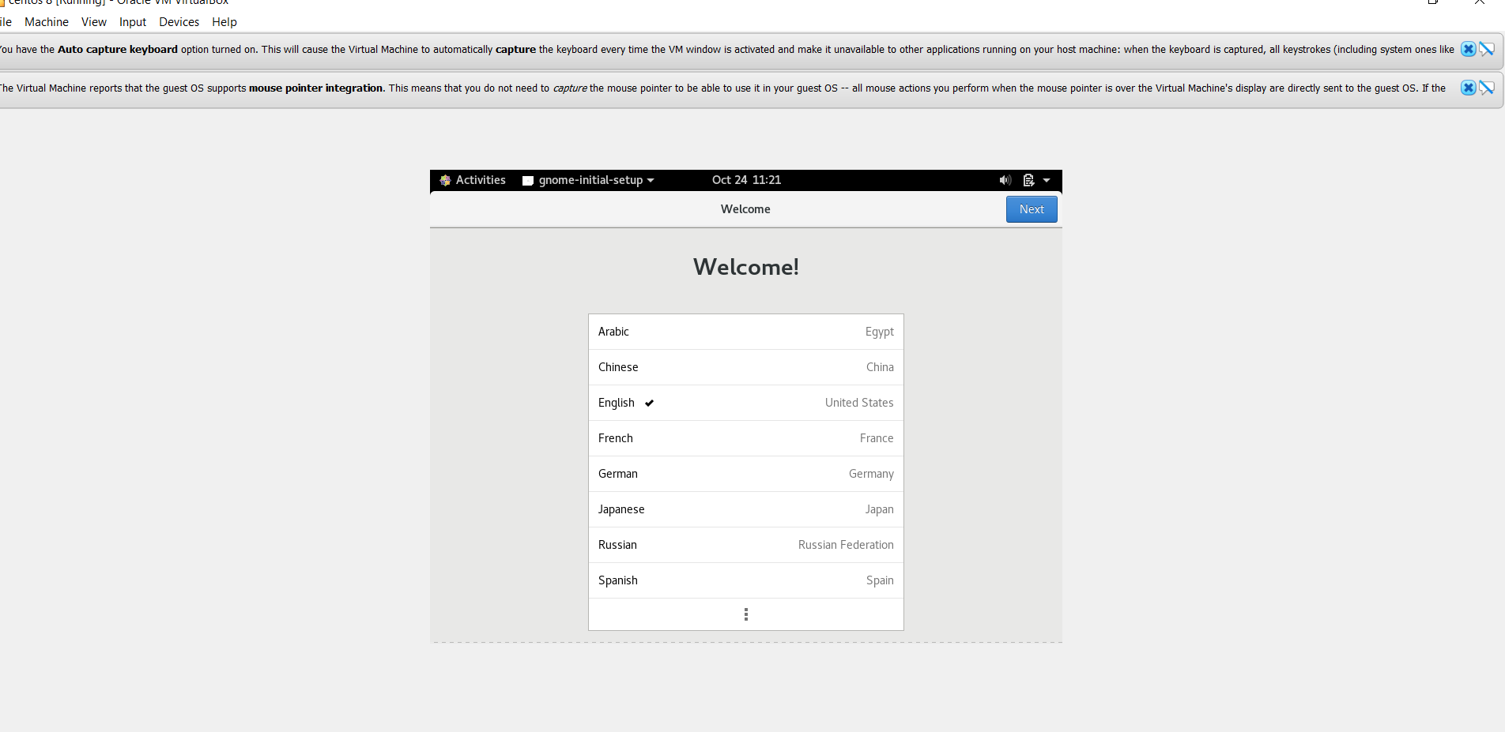

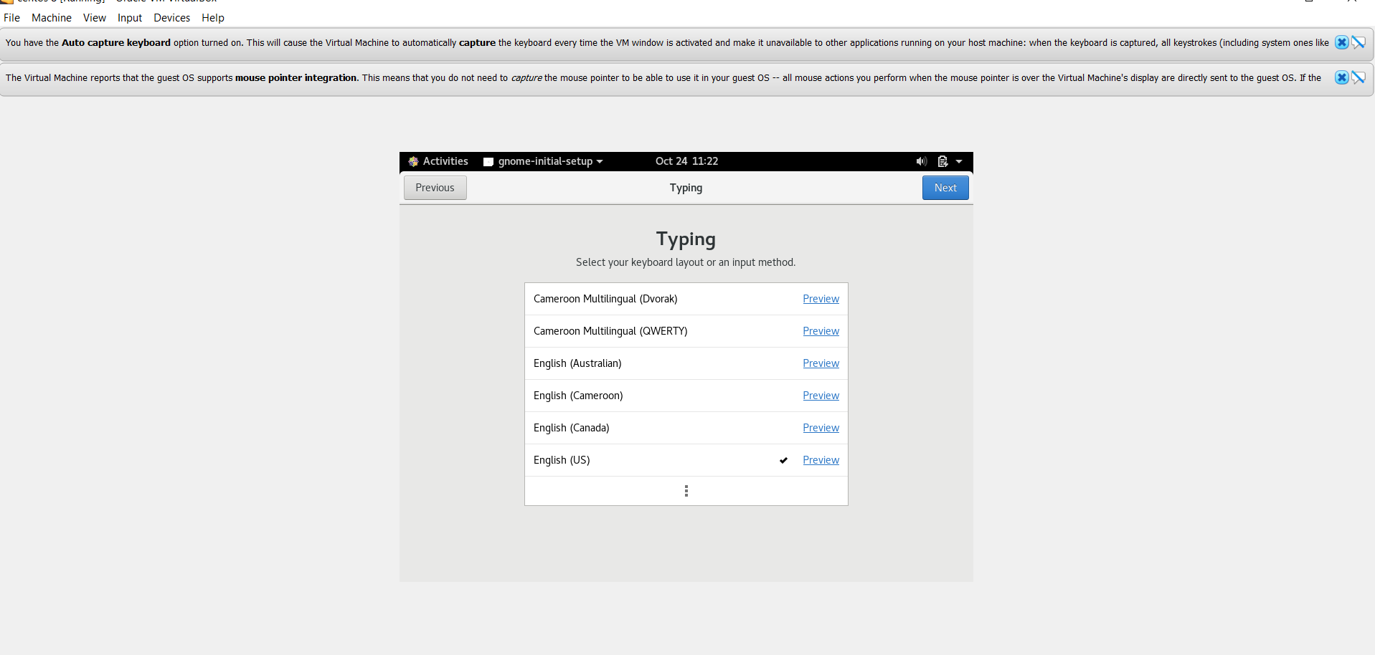

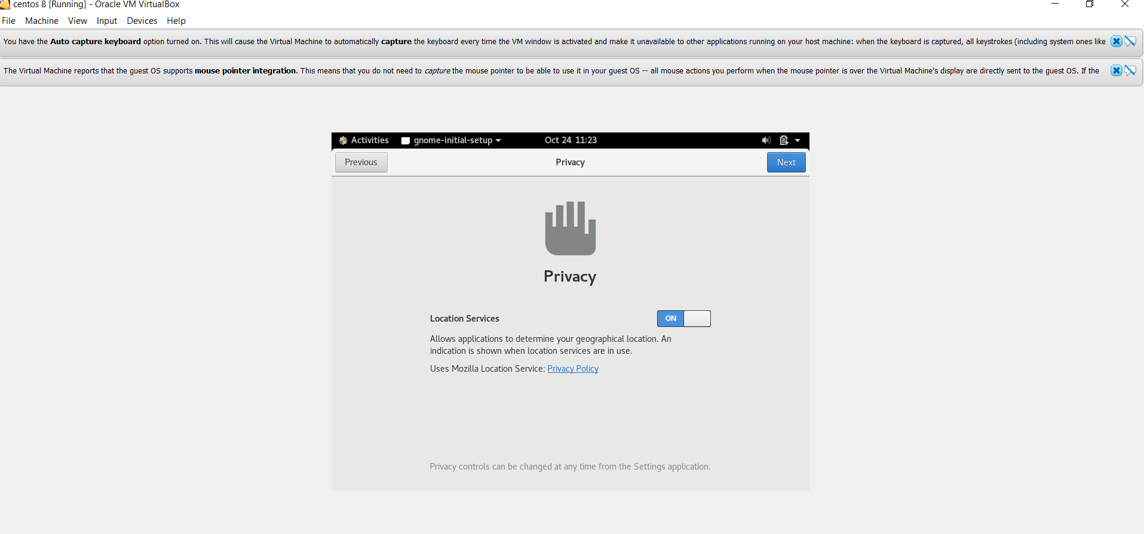

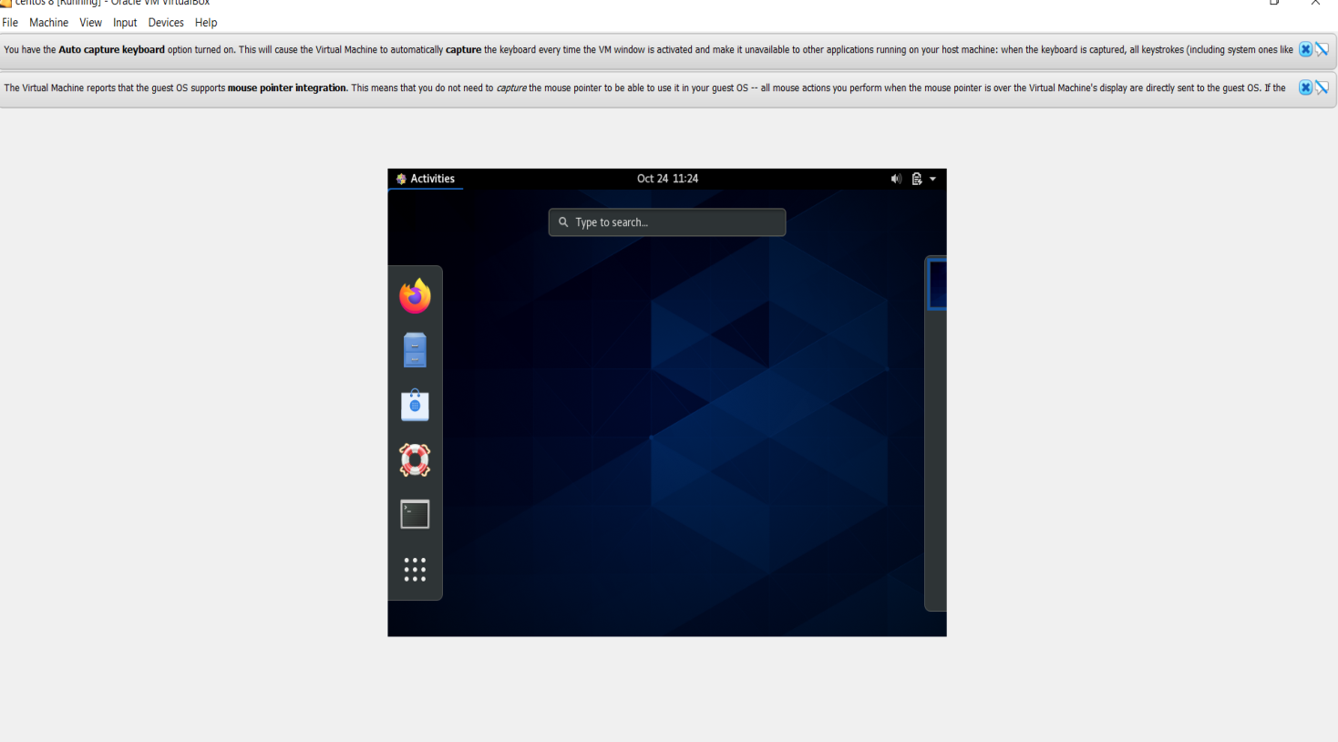

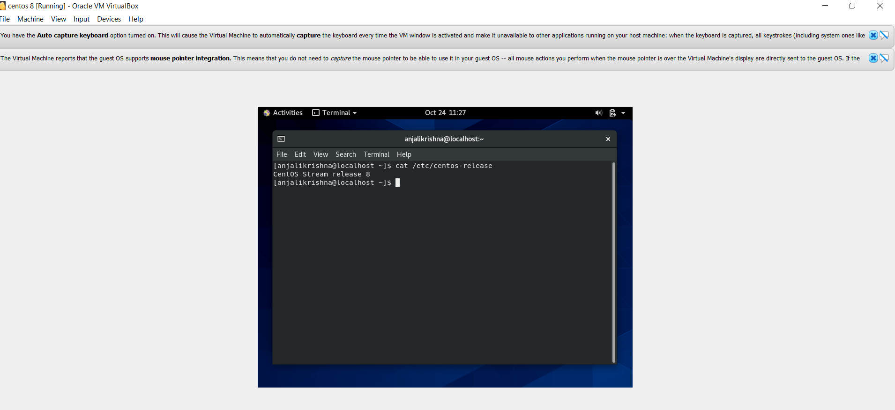

**1)what is kernel ?**

**Kernel is central component of an operating system that manages operations of computer and hardware. It basically manages operations of memory and CPU time. It is core component of an operating system. Kernel acts as a bridge between applications and data processing performed at hardware level using inter-process communication and system calls.**

**Kernel loads first into memory when an operating system is loaded and remains into memory until operating system is shut down again. It is responsible for various tasks such as disk management, task management, and memory management**.**It decides which process should be allocated to processor to execute and which process should be kept in main memory to execute. It basically acts as an interface between user applications and hardware. The major aim of kernel is to manage communication between software i.e. user-level applications and hardware i.e., CPU and disk memory.**

**Kernel function:**

**SVM algorithms use a set of mathematical functions that are defined as the kernel. The function of kernel is to take data as input and transform it into the required form. Different SVM algorithms use different types of kernel functions. These functions can be different types. For example linear, nonlinear,** **polynomial, radial basis function (RBF), and sigmoid.**

**Introduce Kernel functions for sequence data, graphs, text, images, as well as vectors. The most used type of kernel function is RBF. Because it has localized and finite response along the entire x-axis.**

**The kernel functions return the inner product between two points in a suitable feature space. Thus by defining a notion of similarity, with little computational cost even in very high-dimensional spaces.**

**2) what is shell ?**

**Shell is a UNIX term for the interactive user interface with an operating system. The shell is the layer of programming that understands and executes the commands a user enters. In some systems, the shell is called a command interpreter.**

**The shell is the outermost layer of the operating system. Shells incorporate a programming language to control processes and files, as well as to start and control other programs. The shell manages the interaction between you and the operating system by prompting you for input, interpreting that input for the operating system, and then handling any resulting output from the operating system.**

**Shells provide a way for you to communicate with the operating system. This communication is carried out either interactively (input from the keyboard is acted upon immediately) or as a shell script. A shell script is a sequence of shell and operating system commands that is stored in a file.**

**When you log in to the system, the system locates the name of a shell program to execute. After it is executed, the shell displays a command prompt. This prompt is usually a $ (dollar sign). When you type a command at the prompt and press the Enter key, the shell evaluates the command and attempts to carry it out. Depending on your command instructions, the shell writes the command output to the screen or redirects the output. It then returns the command prompt and waits for you to type another command.**

**3) what is operating system?**

**An Operating System (OS) is a software that acts as an interface between computer hardware components and the user. Every computer system must have at least one operating system to run other programs. Applications like Browsers, MS Office, Notepad Games, etc., need some environment to run and perform its tasks.**

**The OS helps you to communicate with the computer without knowing how to speak the computer’s language. It is not possible for the user to use any computer or mobile device without having an operating system.**

**4) what are the component of an oc?**

**An operating system is a large and complex system that can only be created by partitioning into small pieces. These pieces should be a well-defined portion of the system, which carefully defined inputs, outputs, and functions.Although Mac, Unix, Linux, Windows, and other OS do not have the same structure, most of the operating systems share similar OS system components like File, Process, Memory, I/O device management.**

* **Process Management.**
* **File Management.**
* **Network Management.**
* **Main Memory Management.**
* **Secondary Storage Management.**
* **I/O Device Management.**
* **Security Management.**
* **Command Interpreter System.**

1. **File Management**

**A file is a set of related information which is should define by its creator. It commonly represents programs, both source and object forms, and data. Data files can be numeric, alphabetic, or alphanumeric.**

1. **Process management**

**The process management component is a procedure for managing the many processes that are running simultaneously on the operating system. Every software application program has one or more processes associated with them when they are running.**

**For example, when you use a browser like Google Chrome, there is a process running for that browser program. The OS also has many processes running, which performing various functions.All these processes should be managed by process management, which keeps processes for running efficiently. It also uses memory allocated to them and shutting them down when needed.The execution of a process must be sequential so, at least one instruction should be executed on behalf of the process.**

1. **I/O Device Management**

**One of the important use of an operating system that helps you to hide the variations of specific hardware devices from the user.**

1. **Network Management**

**Network management is the process of administering and managing computer networks. It includes performance management, fault analysis, provisioning of networks, and maintaining the quality of service.A distributed system is a collection of computers/processors that never share their own memory or a clock. In this type of system, all the processors have their local Memory, and the processors communicate with each other using different communication lines, like fiber optics or telephone lines.The computers in the network are connected through a communication network, which can be configured in a number of different ways. With the help of network management, the network can be fully or partially connected, which helps users to design routing and connection strategies that overcome connection and security issues.**

1. **Main Memory management**

**Main Memory is a large array of storage or bytes, which has an address. The memory management process is conducted by using a sequence of reads or writes of specific memory addresses.In order to execute a program , it should be mapped to absolute addresses and loaded inside the Memory. The selection of a memory management method depends on several factors.However, it is mainly based on the hardware design of the system. Each algorithm requires corresponding hardware support. Main Memory offers fast storage that can be accessed directly by the CPU. It is costly and hence has a lower storage capacity. However, for a program to be executed, it must be in the main Memory.**

1. **Secondary-Storage Management**

**The most important task of a computer system is to execute programs. These programs, along with the data, helps you to access, which is in the main memory during execution.This Memory of the computer is very small to store all data and programs permanently. The computer system offers secondary storage to back up the main Memory. Today modern computers use hard drives/SSD as the primary storage of both programs and data. However, the secondary storage management also works with storage devices, like a USB flash drive, and CD/DVD drives.Programs like assemblers, compilers, stored on the disk until it is loaded into memory, and then use the disk as a source and destination for processing.**

1. **Security Management**

**The various processes in an operating system need to be secured from each other’s activities. For that purpose, various mechanisms can be used to ensure that those processes which want to operate files, memory CPU, and other hardware resources should have proper authorization from the operating system.**